
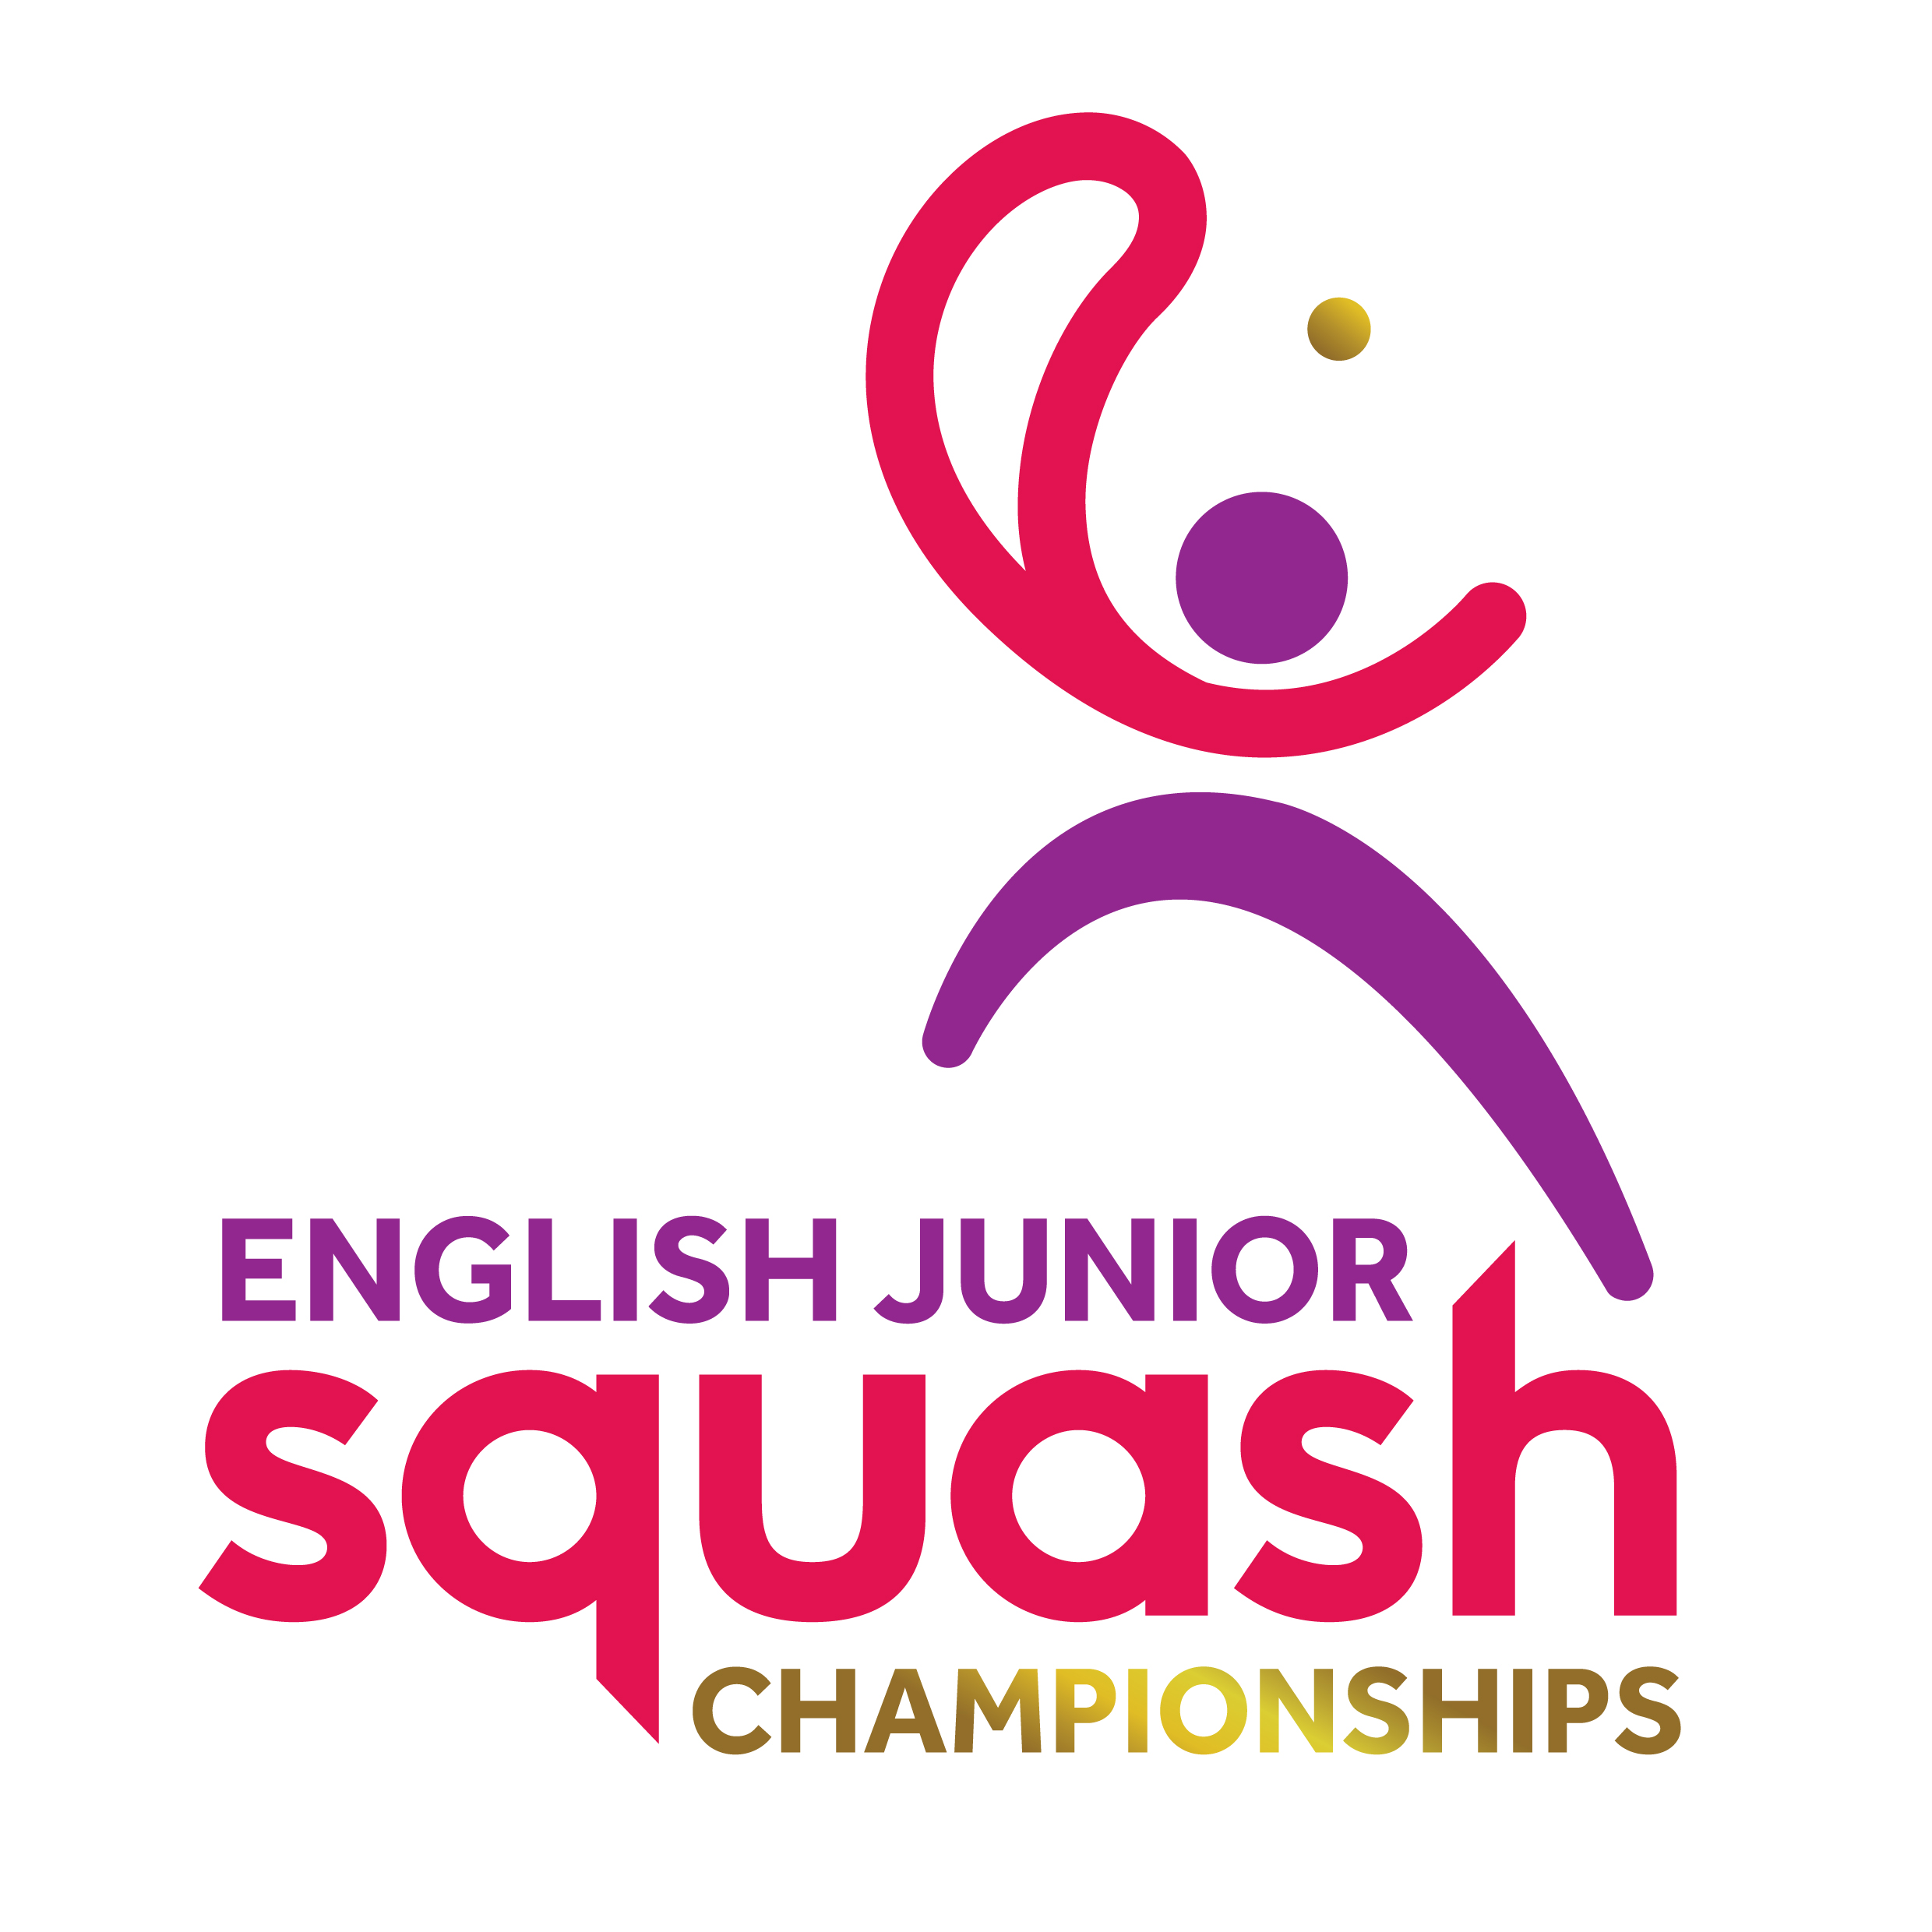

ENGLISH JUNIOR CHAMPIONSHIPS 2017
BOYS UNDER 15

First Round | Court Time | Results
[1] Sam Todd  Malik Bilen | FRI 09.30  EPC C1 | Sam Todd  3-0 11/4, 11/7, 11/7
[9/16] Franklyn Smith  Tymour Saba | FRI 09.30  EPC C2 | Franklyn Smith  3-2 11/5, 7/11, 11/7, 6/11, 11/4
[9/16] Muhammad Azhan Khan  Toby Ponting | FRI 09.30  EPC C3 | Muhammad Azhan Khan  3-0 12/10, 11/8, 11/9
[5/8] Hassan Khalil  Laurence Cull | FRI 09.30  EPC C4 | Hassan Khalil  3-0 11/2, 11/2, 11/8
[5/8] Jack Bloomfield  Ben Harrison | FRI 09.30  EPC C7 | Jack Bloomfield  8/11, 11/8, 11/7, 13/11
[9/16] Oliver Green  Jordan Stewart | FRI 09.30  EPC C8 | Oliver Green  3-0 11/2, 11/9, 11/5
[9/16] Kian Howard  Ben Perkins | FRI 09.30  EPC C9 | Kian Howard  3-0 11/5, 11/3, 11/3
[3/4] Josh Perkins  Luca Campbell-Wynter | FRI 09.30  EPC C10 | Josh Perkins  3-0 11/5, 11/4, 11/9
[3/4] Sam Osborne-Wylde  Jake Wild | FRI 10.30  EPC C1 | Sam Osborne-Wylde  3-0 11/3, 11/6, 11/4
[9/16] Joshua Morris  Billy Miles | FRI 10.30  EPC C2 | Joshua Morris  3-1 7/11, 11/5, 11/2, 12/10
[9/16] Jamie Carmichael  Zaid Mushtaq | FRI 10.30  EPC C3 | Jamie Carmichael  3-1 11/6, 11/8, 3/11, 11/8
[5/8] Ben Smith  Ethan Chak | FRI 10.30  EPC C4 | Ben Smith  3-0 11/4, 11/1, 11/4
[5/8] Alfie Lawes  Zan Farooqi | FRI 10.30  EPC C7 | Alfie Lawes  3-0 11/3, 11/9, 11/3
[9/16] James Gibbins  Travis-Jack Tatum | FRI 10.30  EPC C8 | James Gibbins  3-0 11/2, 11/1, 11/3
[9/16] Lewis Harding  George Bidder | FRI 10.30  EPC C9 | Lewis Harding  3-0 11/6, 11/9, 11/3
[2] Adam Goad  Joss Sim-Baskar | FRI 10.30  EPC C10 | Adam Goad  3-0 11/7, 11/5, 11/6

Second Round  Last 16 | Court  Time | Results

Sam Todd | FRI 16.20  EPC C1 | Sam Todd  3-0 11/4, 11/8, 11/4
Franklyn Smith | FRI 16.20  EPC C1 | Sam Todd  3-0 11/4, 11/8, 11/4
Muhammad Azhan Khan | FRI 16.20  EPC C2 | Hassan Khalil  3-1 13/11, 11/5, 5/11, 12/10
Hassan Khalil | FRI 16.20  EPC C2 | Hassan Khalil  3-1 13/11, 11/5, 5/11, 12/10
Jack Bloomfield | FRI 16.20  EPC C3 | Oliver Green  3-0 11/8, 11/6, 11/9
Oliver Green | FRI 16.20  EPC C3 | Oliver Green  3-0 11/8, 11/6, 11/9
Kian Howard | FRI 16.20  EPC C4 | Josh Perkins  3-1 9/11, 11/4, 11/5, 11/2
Josh Perkins | FRI 16.20  EPC C4 | Josh Perkins  3-1 9/11, 11/4, 11/5, 11/2
Sam Osborne-Wylde | FRI 16.20  EPC C7 | Sam Osborne-Wylde  3-1 11/6, 11/6, 8/11, 11/9
Joshua Morris | FRI 16.20  EPC C7 | Sam Osborne-Wylde  3-1 11/6, 11/6, 8/11, 11/9
Jamie Carmichael | FRI 16.20  EPC C8 | Ben Smith  3-0 11/7, 11/1, 11/0
Ben Smith | FRI 16.20  EPC C8 | Ben Smith  3-0 11/7, 11/1, 11/0
Alfie Lawes | FRI 16.20  EPC C9 | Alfie Lawes  3-0 11/8, 12/10, 11/6
James Gibbins | FRI 16.20  EPC C9 | Alfie Lawes  3-0 11/8, 12/10, 11/6
Lewis Harding | FRI 16.20  EPC C10 | Adam Goad  3-0 11/5, 11/6, 14/12
Adam Goad | FRI 16.20  EPC C10 | Adam Goad  3-0 11/5, 11/6, 14/12

Third Round  (2nd round winners competing for places 1 to 8) | Court  Time | Results

Sam Todd | SAT 12:10  EPC C1 | Sam Todd 3-0  11-7 11-7 11-9
Hassan Khalil | SAT 12:10  EPC C1 | Sam Todd 3-0  11-7 11-7 11-9
Oliver Green | SAT 12:10  EPC C2 | Oliver Green 3-1  11-8 10-12 11-4 11-2
Josh Perkins | SAT 12:10  EPC C2 | Oliver Green 3-1  11-8 10-12 11-4 11-2
Sam Osborne-Wylde | SAT 12:10  EPC C3 | Ben Smith 3-1  11-5 11-6 6-11 11-6
Ben Smith | SAT 12:10  EPC C3 | Ben Smith 3-1  11-5 11-6 6-11 11-6
Alfie Lawes | SAT 12:10  EPC C4 | Adam Goad 3-2  9-11 11-3 9-11 11-9 12-10
Adam Goad | SAT 12:10  EPC C4 | Adam Goad 3-2  9-11 11-3 9-11 11-9 12-10

Third Round  (2nd round losers competing for places 9 to 16) | Court  Time | Results

Franklyn Smith | SAT 09:30  EPC C7 | Franklyn Smith 3-1  15-13 11-5 5-11 11-3
Muhammad Azhan Khan | SAT 09:30  EPC C7 | Franklyn Smith 3-1  15-13 11-5 5-11 11-3
Jack Bloomfield | SAT 09:30  EPC C8 | Jack Bloomfield 3-2  14-16 8-11 14-12 11-3 11-7
Kian Howard | SAT 09:30  EPC C8 | Jack Bloomfield 3-2  14-16 8-11 14-12 11-3 11-7
Joshua Morris | SAT 09:30  EPC C9 | Joshua Morris 3-1  9-11 11-4 11-3 11-9
Jamie Carmichael | SAT 09:30  EPC C9 | Joshua Morris 3-1  9-11 11-4 11-3 11-9
James Gibbins | SAT 09:30  EPC C10 | James Gibbins 3-0  11-9 11-9 11-9
Lewis Harding | SAT 09:30  EPC C10 | James Gibbins 3-0  11-9 11-9 11-9

Fourth Round  (3rd round winners 1 to 8 competing for places 1 to 4) | Court  Time | Results

Sam Todd | SAT 17:40  EPC C4 | Sam Todd 3-0  11-8 14-12 11-5
Oliver Green | SAT 17:40  EPC C4 | Sam Todd 3-0  11-8 14-12 11-5
Ben Smith | SAT 17:40  EPC C7 | Ben Smith 3-1  12-10 11-5 8-11 11-6
Adam Goad | SAT 17:40  EPC C7 | Ben Smith 3-1  12-10 11-5 8-11 11-6

Fourth Round  (3rd round losers 1 to 8 competing for places 5 to 8) | Court  Time | Results

Hassan Khalil | SAT 19:00  EPC C7 | Hassan Khalil 3-0  11-5 12-10 11-5
Josh Perkins | SAT 19:00  EPC C7 | Hassan Khalil 3-0  11-5 12-10 11-5
Sam Osbourne-Wylde | SAT 19:00  EPC C8 | Alfie Lawes 3-2  11-7 11-6 6-11 6-11 11-8
Alfie Lawes | SAT 19:00  EPC C8 | Alfie Lawes 3-2  11-7 11-6 6-11 6-11 11-8

Fourth Round  (3rd round winners 9 to 16 competing for places 9 to 12) | Court  Time | Results

Franklyn Smith | SAT 14:40  EPC C1 | Franklyn Smith 3-2  10-12 7-11 11-6 11-8 12-10
Jack Bloomfield | SAT 14:40  EPC C1 | Franklyn Smith 3-2  10-12 7-11 11-6 11-8 12-10
Joshua Morris | SAT 14:40  EPC C2 | Joshua Morris 3-1  7-11 11-7 11-9 11-5
James Gibbins | SAT 14:40  EPC C2 | Joshua Morris 3-1  7-11 11-7 11-9 11-5

Fourth Round  (3rd round losers 9 to 16 competing for places 13 to 16) | Court  Time | Results

Muhammad Azhan Khan | SAT 14:40  EPC C3 | Muhammad Azhan Khan 3-0  11-4 11-4 13-11
Kian Howard | SAT 14:40  EPC C3 | Muhammad Azhan Khan 3-0  11-4 11-4 13-11
Jamie Carmichael | SAT 14:40  EPC C3 | Lewis Harding 3-0  11-6 11-5 11-8
Lewis Harding | SAT 14:40  EPC C3 | Lewis Harding 3-0  11-6 11-5 11-8

Court  Time | Final / Play-Offs | Result | Final Position | Final  Place

SUN  13:20  EPC C3 | Sam Todd | 3-1  7-11 11-4 11-4 11-2 | Sam Todd | 1
SUN  13:20  EPC C3 | Ben Smith | 3-1  7-11 11-4 11-4 11-2 | Ben Smith | 2
SUN  14:10  EPC C8 | Oliver Green | 3-1  11-7 11-9 3-11 11-7 | Adam Goad | 3
SUN  14:10  EPC C8 | Adam Goad | 3-1  11-7 11-9 3-11 11-7 | Oliver Green | 4
SUN  10:00  EPC C3 | Hassan Khalil | 3-0  11-9 11-3 11-8 | Hassan Khalil | 5
SUN  10:00  EPC C3 | Alfie Lawes | 3-0  11-9 11-3 11-8 | Alfie Lawes | 6
SUN  10:00  EPC C4 | Josh Perkins | 3-2  12-10 11-8 11-13 9-11 11-9 | Josh Perkins | 7
SUN  10:00  EPC C4 | Sam Osbourne-Wylde | 3-2  12-10 11-8 11-13 9-11 11-9 | Sam Osbourne-Wylde | 8
SUN  10:00  EPC C7 | Franklyn Smith | 3-0  14-12 11-9 12-10 | Franklyn Smith | 9
SUN  10:00  EPC C7 | Joshua Morris | 3-0  14-12 11-9 12-10 | Joshua Morris | 10
SUN  10:00  EPC C8 | Jack Bloomfield | 3-0  11-7 11-1 11-7 | James Gibbons | 11
SUN  10:00  EPC C8 | James Gibbons | 3-0  11-7 11-1 11-7 | Jack Bloomfield | 12
SUN  10:00  EPC C9 | Muhammad Azhan Khan | W/O | Lewis Harding | 13
SUN  10:00  EPC C9 | Lewis Harding | W/O | Muhammad Azhan Khan | 14
SUN  10:00  EPC C10 | Kian Howard | 3-0  11-7 11-8 11-5 | Jamie Carmichael | 15
SUN  10:00  EPC C10 | Jamie Carmichael | 3-0  11-7 11-8 11-5 | Kian Howard | 16

