
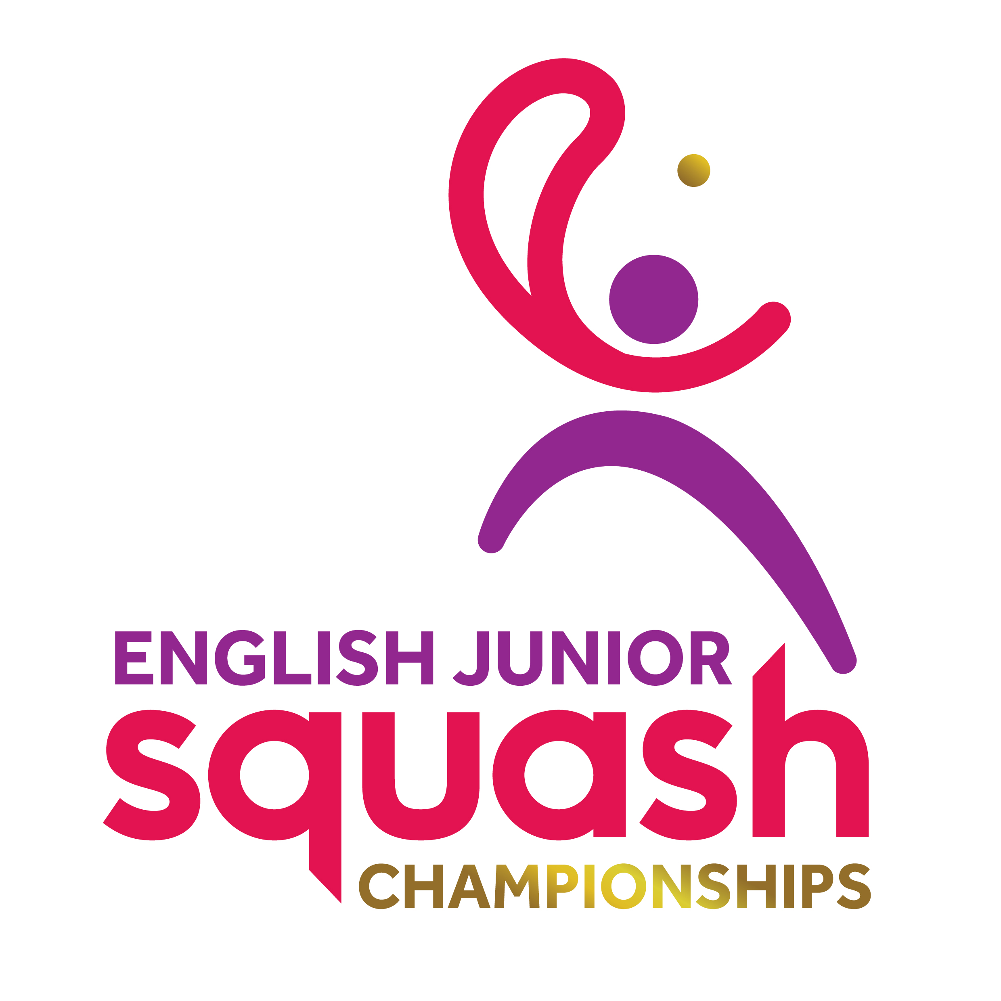

ENGLISH JUNIOR CHAMPIONSHIPS 2017
BOYS UNDER 13

First Round | Court Time | Results
[1] Jonah Bryant  James Averill | FRI 10.00  UOB C1 | J. Bryant 3-0 11-1 11-4 11-1
[9/16] Cory Harding  Joseph Royle | FRI 10.00  UOB C2 | C. Harding 3-0 11-6 11-9 11-9
[9/16] Harry Bloomfield  Joe Pannell | FRI10.00  UOB C3 | H. Bloomfield 3-1  9-11 13-11 11-7 11-3
James Campbell-Wynter  Jake Sim-Baskar | FRI 10.00  UOB C4 | J. Campbell-Wynter 3-0 11-9 11-5 11-4
[5/8] Arhan Chandra  Luke Perkins | FRI 10.00  UOB C5 | A. Chandra 3-0 11-8 11-7 11-9
[9/16] Christopher Chak  Bailey Malik | FRI 10.00  UOB C6 | C. Chak 3-1 12-10 6-11 15-13 11-4
[9/16] James Kettle  Thomas Greengrass | FRI 10.30  UOB C1 | J. Kettle 3-0 11-6 11-4 11-5
[3/4] Finnlay Withington  James Carman | FRI 10.30  UOB C2 | F. Withington 3-0 11-6 11-4 11-2
[3/4] Ashley Hughes  Heston Malik | FRI 10.30  UOB C3 | A. Hughes 3-0 11-2 11-3 11-6
[9/16] Alex Mullis  Nero Harms | FRI 10.30  UOB C4 | N. Harms 3-0 11-7 12-10 12-10
[9/16] Jack Mahon  Oliver Coulcher-Porter | FRI 10.30  UOB C5 | J. Mahon 3-0 11-7 11-4 11-7
[5/8] Caleb Boy  Mehul Chopra | FRI 10.30  UOB C6 | C. Boy 3-0 11-5 11-1 11-6
[5/8] Yusuf Sheikh  Alexander Broadbridge | FRI 11.00  UOB C3 | Yusuf Sheikh 3-0 11-2 11-6 11-3
[9/16] Ben Parlour  Louis Murray | FRI 11.00  UOB C4 | B. Parlour 3-1 6-11 11-5 11-8 11-3
Eden Spooner  [9/16] Jack Whitfield | FRI 11.00  UOB C5 | J. Whitfield 3-0 11-3 11-4 11-3
[2] Ben Beachill | FRI 11.00  UOB C6 | B. Beachill 3-0 11-6
11-6 11-4

Second Round  Last 16 | Court  Time | Results

Jonah Bryant | FRI 16.20  UOB C1 | Jonah Bryant 3-0  11-2 11-4 11-4
Cory Harding | FRI 16.20  UOB C1 | Jonah Bryant 3-0  11-2 11-4 11-4
Harry Bloomfield | FRI 16.20  UOB C2 | Harry Bloomfield 3-0 11-5 11-8 11-4
James Campbell-Wynter | FRI 16.20  UOB C2 | Harry Bloomfield 3-0 11-5 11-8 11-4
Arhan Chandra | FRI 16.20  UOB C3 | Christopher Chak 3-1 11-2 9-11 11-9 11-9
Christopher Chak | FRI 16.20  UOB C3 | Christopher Chak 3-1 11-2 9-11 11-9 11-9
James Kettle | FRI 16.20  UOB C4 | Finnlay Withington 3-0 11-5 11-8 11-8
Finnlay Withington | FRI 16.20  UOB C4 | Finnlay Withington 3-0 11-5 11-8 11-8
Ashley Hughes | FRI 16.20  UOB C5 | Ashley Hughes 3-0 11-8 11-5 11-9
Nero Harms | FRI 16.20  UOB C5 | Ashley Hughes 3-0 11-8 11-5 11-9
Jack Mahon | FRI 16.20  UOB C6 | Jack Mahon 3-2 4-11 14-12 9-11 11-5 12-10
Caleb Boy | FRI 16.20  UOB C6 | Jack Mahon 3-2 4-11 14-12 9-11 11-5 12-10
Yusuf Sheikh | FRI 17.00  UOB C1 | Yusuf Sheikh 3-2 4-11 11-6 7-11 14-12 12-10
Ben Parlour | FRI 17.00  UOB C1 | Yusuf Sheikh 3-2 4-11 11-6 7-11 14-12 12-10
Jack Whitfield | FRI 17.00  UOB C2 | Ben Beachill 3-0  11-8 11-8 11-6
Ben Beachill | FRI 17.00  UOB C2 | Ben Beachill 3-0  11-8 11-8 11-6

Third Round  (2nd round winners competing for places 1 to 8) | Court  Time | Results

Jonah Bryant | SAT 11:30  EPC C7 | Jonah Bryant 3-0  11-6 11-3 11-5
Harry Bloomfield | SAT 11:30  EPC C7 | Jonah Bryant 3-0  11-6 11-3 11-5
Christopher Chak | SAT 11:30  EPC C8 | Finnlay Withington 3-0  11-4 11-2 11-4
Finnlay Withington | SAT 11:30  EPC C8 | Finnlay Withington 3-0  11-4 11-2 11-4
Ashley Hughes | SAT 11:30  EPC C9 | Ashley Hughes 3-0  11-4 11-4 11-3
Jack Mahon | SAT 11:30  EPC C9 | Ashley Hughes 3-0  11-4 11-4 11-3
Yusuf Sheikh | SAT 11:30  EPC C10 | Ben Beachill 3-0  11-1 11-7 11-7
Ben Beachill | SAT 11:30  EPC C10 | Ben Beachill 3-0  11-1 11-7 11-7

Third Round  (2nd round losers competing for places 9 to 16) | Court  Time | Results

Cory Harding | SAT 09:30  EPC C1 | James Campbell-Wynter  3-2 14-12 13-11 4-11 7-11 11-9
James Campbell-Wynter | SAT 09:30  EPC C1 | James Campbell-Wynter  3-2 14-12 13-11 4-11 7-11 11-9
Arhan Chaudra | SAT 09:30  EPC C2 | James Kettle 3-0  11-7 11-8 11-7
James Kettle | SAT 09:30  EPC C2 | James Kettle 3-0  11-7 11-8 11-7
Nero Harms | SAT 09:30  EPC C3 | Caleb Boy 3-1  11-3 11-5 14-16 12-10
Caleb Boy | SAT 09:30  EPC C3 | Caleb Boy 3-1  11-3 11-5 14-16 12-10
Ben Parlour | SAT 09:30  EPC C4 | Ben Parlour 3-0  11-5 Rtd
Jack Whitfield | SAT 09:30  EPC C4 | Ben Parlour 3-0  11-5 Rtd

Fourth Round  (3rd round winners 1 to 8 competing for places 1 to 4) | Court  Time | Results

Jonah Bryant | SAT 17:40  EPC C2 | Jonah Bryant 3-0  11-7 11-3 11-3
Finnlay Withington | SAT 17:40  EPC C2 | Jonah Bryant 3-0  11-7 11-3 11-3
Ashley Hughes | SAT 17:40  EPC C9 | Ben Beachill 3-0  11-9 11-3 11-5
Ben Beachill | SAT 17:40  EPC C9 | Ben Beachill 3-0  11-9 11-3 11-5

Fourth Round  (3rd round losers 1 to 8 competing for places 5 to 8) | Court  Time | Results

Harry Bloomfield | SAT 18:20  EPC C9 | Christopher Chak 3-1  11-6 11-4 10-12 11-7
Christopher Chak | SAT 18:20  EPC C9 | Christopher Chak 3-1  11-6 11-4 10-12 11-7
Jack Mahon | SAT 18:20  EPC C10 | Yusef Sheikh 3-0  11-7 11-7 11-8
Yusef Sheikh | SAT 18:20  EPC C10 | Yusef Sheikh 3-0  11-7 11-7 11-8

Fourth Round  (3rd round winners 9 to 16 competing for places 9 to 12) | Court  Time | Results

James Campbell-Wynter | SAT 15:10  EPC C7 | James Kettle 3-0  11-3 11-6 11-6
James Kettle | SAT 15:10  EPC C7 | James Kettle 3-0  11-3 11-6 11-6
Caleb Boy | SAT 15:10  EPC C8 | Caleb Boy 3-0  11-4 11-9 11-7
Jack Whitfield | SAT 15:10  EPC C8 | Caleb Boy 3-0  11-4 11-9 11-7

Fourth Round  (3rd round losers 9 to 16 competing for places 13 to 16) | Court  Time | Results

Cory Harding | SAT 15:10  EPC C9 | Arhan Chandra 3-0  11-6 11-3 11-5
Arhan Chandra | SAT 15:10  EPC C9 | Arhan Chandra 3-0  11-6 11-3 11-5
Nero Harms | SAT 15:10  EPC C10 | Nero Harms  W/O
Ben Parlour | SAT 15:10  EPC C10 | Nero Harms  W/O

Court  Time | Final / Play-Offs | Result | Final Position | Final  Place

SUN 12:20 EPC C2 | Jonah Bryant | 3-1  11-8 19-17 5-11 11-8 | Jonah Bryant | 1
SUN 12:20 EPC C2 | Ben Beachill | 3-1  11-8 19-17 5-11 11-8 | Ben Beachill | 2
SUN 12:20 EPC C4 | Finnlay Withington | 3-0  11-3 11-8 11-3 | Finnlay Withington | 3
SUN 12:20 EPC C4 | Ashley Hughes | 3-0  11-3 11-8 11-3 | Ashley Hughes | 4
SUN 09:00 EPC C9 | Christopher Chak | 3-2  11-7 9-11 4-11 11-5 11-3 | Yusef Sheikh | 5
SUN 09:00 EPC C9 | Yusef Sheikh | 3-2  11-7 9-11 4-11 11-5 11-3 | Christopher Chak | 6
SUN 09:00 EPC C10 | Harry Bloomfield | 3-0  13-11 11-9 11-3 | Jack Mahon | 7
SUN 09:00 EPC C10 | Jack Mahon | 3-0  13-11 11-9 11-3 | Harry Bloomfield | 8
SUN 09:30 EPC C1 | James Kettle | 3-1  11-1 12-10 9-11 11-8 | Caleb Boy | 9
SUN 09:30 EPC C1 | Caleb Boy | 3-1  11-1 12-10 9-11 11-8 | James Kettle | 10
SUN 09:30 EPC C2 | James Campbell-Wynter | 3-0  12-10 11-6 11-6 | Jack Whitfield | 11
SUN 09:30 EPC C2 | Jack Whitfield | 3-0  12-10 11-6 11-6 | James Campbell-Wynter | 12
SUN 09:30 EPC C3 | Arhan Chandra | 3-2  10-12 11-7 9-11 15-13 11-9 | Nero Harms | 13
SUN 09:30 EPC C3 | Nero Harms | 3-2  10-12 11-7 9-11 15-13 11-9 | Arhan Chandra | 14
SUN 09:30 EPC C4 | Cory Harding | W/O | Cory Harding | 15
SUN 09:30 EPC C4 | Ben Parlour | W/O | Ben Parlour | 16

