
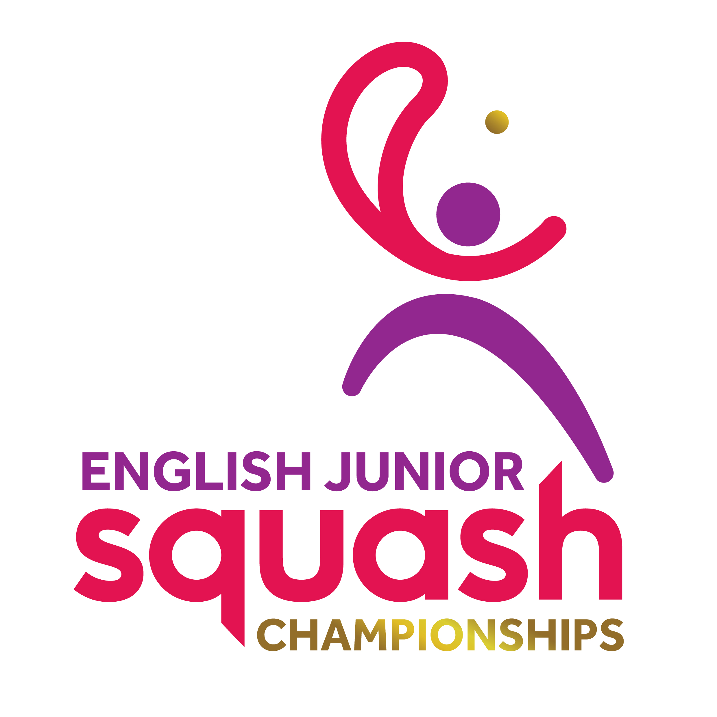

ENGLISH JUNIOR CHAMPIONSHIPS 2017
Round 1 | Q Finals | S Finals | Final
Ellie Thomas | Charlie Mccrone  11/2, 17/15, 11/9
Charlie Mccrone

Lily Main | Sophie Bolland  11/4, 11/2, 11/6
Sophie Bolland |  | Sophie Bolland  7/11, 12/10, 11/6, 11/7
Lottie Hill | Florence Kersley 11/7, 18/16, 9/11, 11/8
Florence Kersley

Sophia Lee | Trinity Roberton 6/11, 16/14, 9/11, 11/8, 11/6
Trinity Roberton |  | Trinity Roberton  9/11, 11/9, 13/11, 13/11 | Sophie Bolland  3-0  11/2, 11/6, 11/5
Renitha Srindran | Renitha Srindran  11/5, 7/11, 12/10, 11/4 | Hannah Rowley 11/3, 11/8, 11/7 | Hannah Rowley  3-0  12/10, 11/2, 11/5
Mariam Eissa

Hannah Rowley | Hannah Rowley  11/3, 11/3, 14/12
Isabel Sargent

Lara Newton | Amy Fargemann  8/11, 11/6, 11/9, 12/10 | Natalie Samir  12/10, 11/1, 11/7
Amy Fargemann

Natalie Samir | Natalie Samir  11/5, 5/11, 6/11, 11/5, 11/6
Emily Coulcher-Porter

GIRLS UNDER 13 PLATE

Sophie Bolland
3-0
11/9, 11/7,
11/3

