
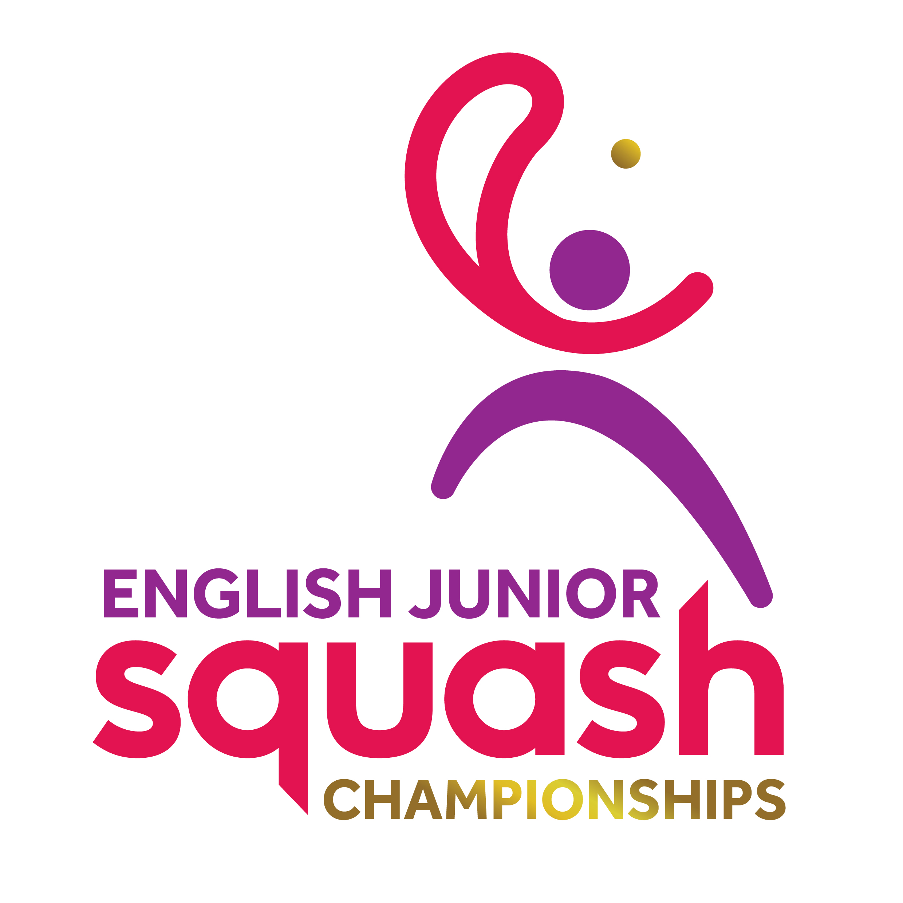

ENGLISH JUNIOR CHAMPIONSHIPS 2017
Round 1 | Q Finals | S Finals | Final
Bye | Chloe Foster
Chloe Foster
Aisha Forster | Katie Cox 3-0
Katie Cox | 11-4 11-6 11-6 | Katie Cox  11/6, 11/7, 11/5
Polly Clark | Polly Clark 3-2
Natalie Chak | 11-7 9-11 11-5  7-11 11-4
Pheobe Colman | Pheobe Colman 3-2 | Polly Clark  11/8, 11/9, 9/11, 1/11, 11/8
Lottie Taylor-French | 4-11 11-8 11-13 14-12  13-11 |  | Katie Cox  9/11, 12/10, 4/11, 11/3, 11/5
Amy Aspinall | Amy Aspinall 3-1 |  | Sydney Wallace  11/2, 11/4, 4/11, 9/11, 11/6
Piper Rose Tatum | 7-11 12-10 11-8 11-5 | Lowri Waugh  11/9, 12/10, 6/11, 8/11, 16/14
Alysha Martin | Lowri Waugh 3-0
Lowri Waugh | 11-7 11-6 11-7
Paige McCoy | Darcie-Rose Mounter 3-1 | Sydney Wallace  w/o
Darcie-Rose Mounter | 11-3 11-7 6-11 11-9
Elli Barrott | Sydney Wallace 3-0
Sydney Wallace | 11-5 11-7 11-8

GIRLS UNDER 17 PLATE

FINAL
SUN
11.00
UOB C2

Katie Cox WINS 3-0
11/1, 11/6, 11/5

