
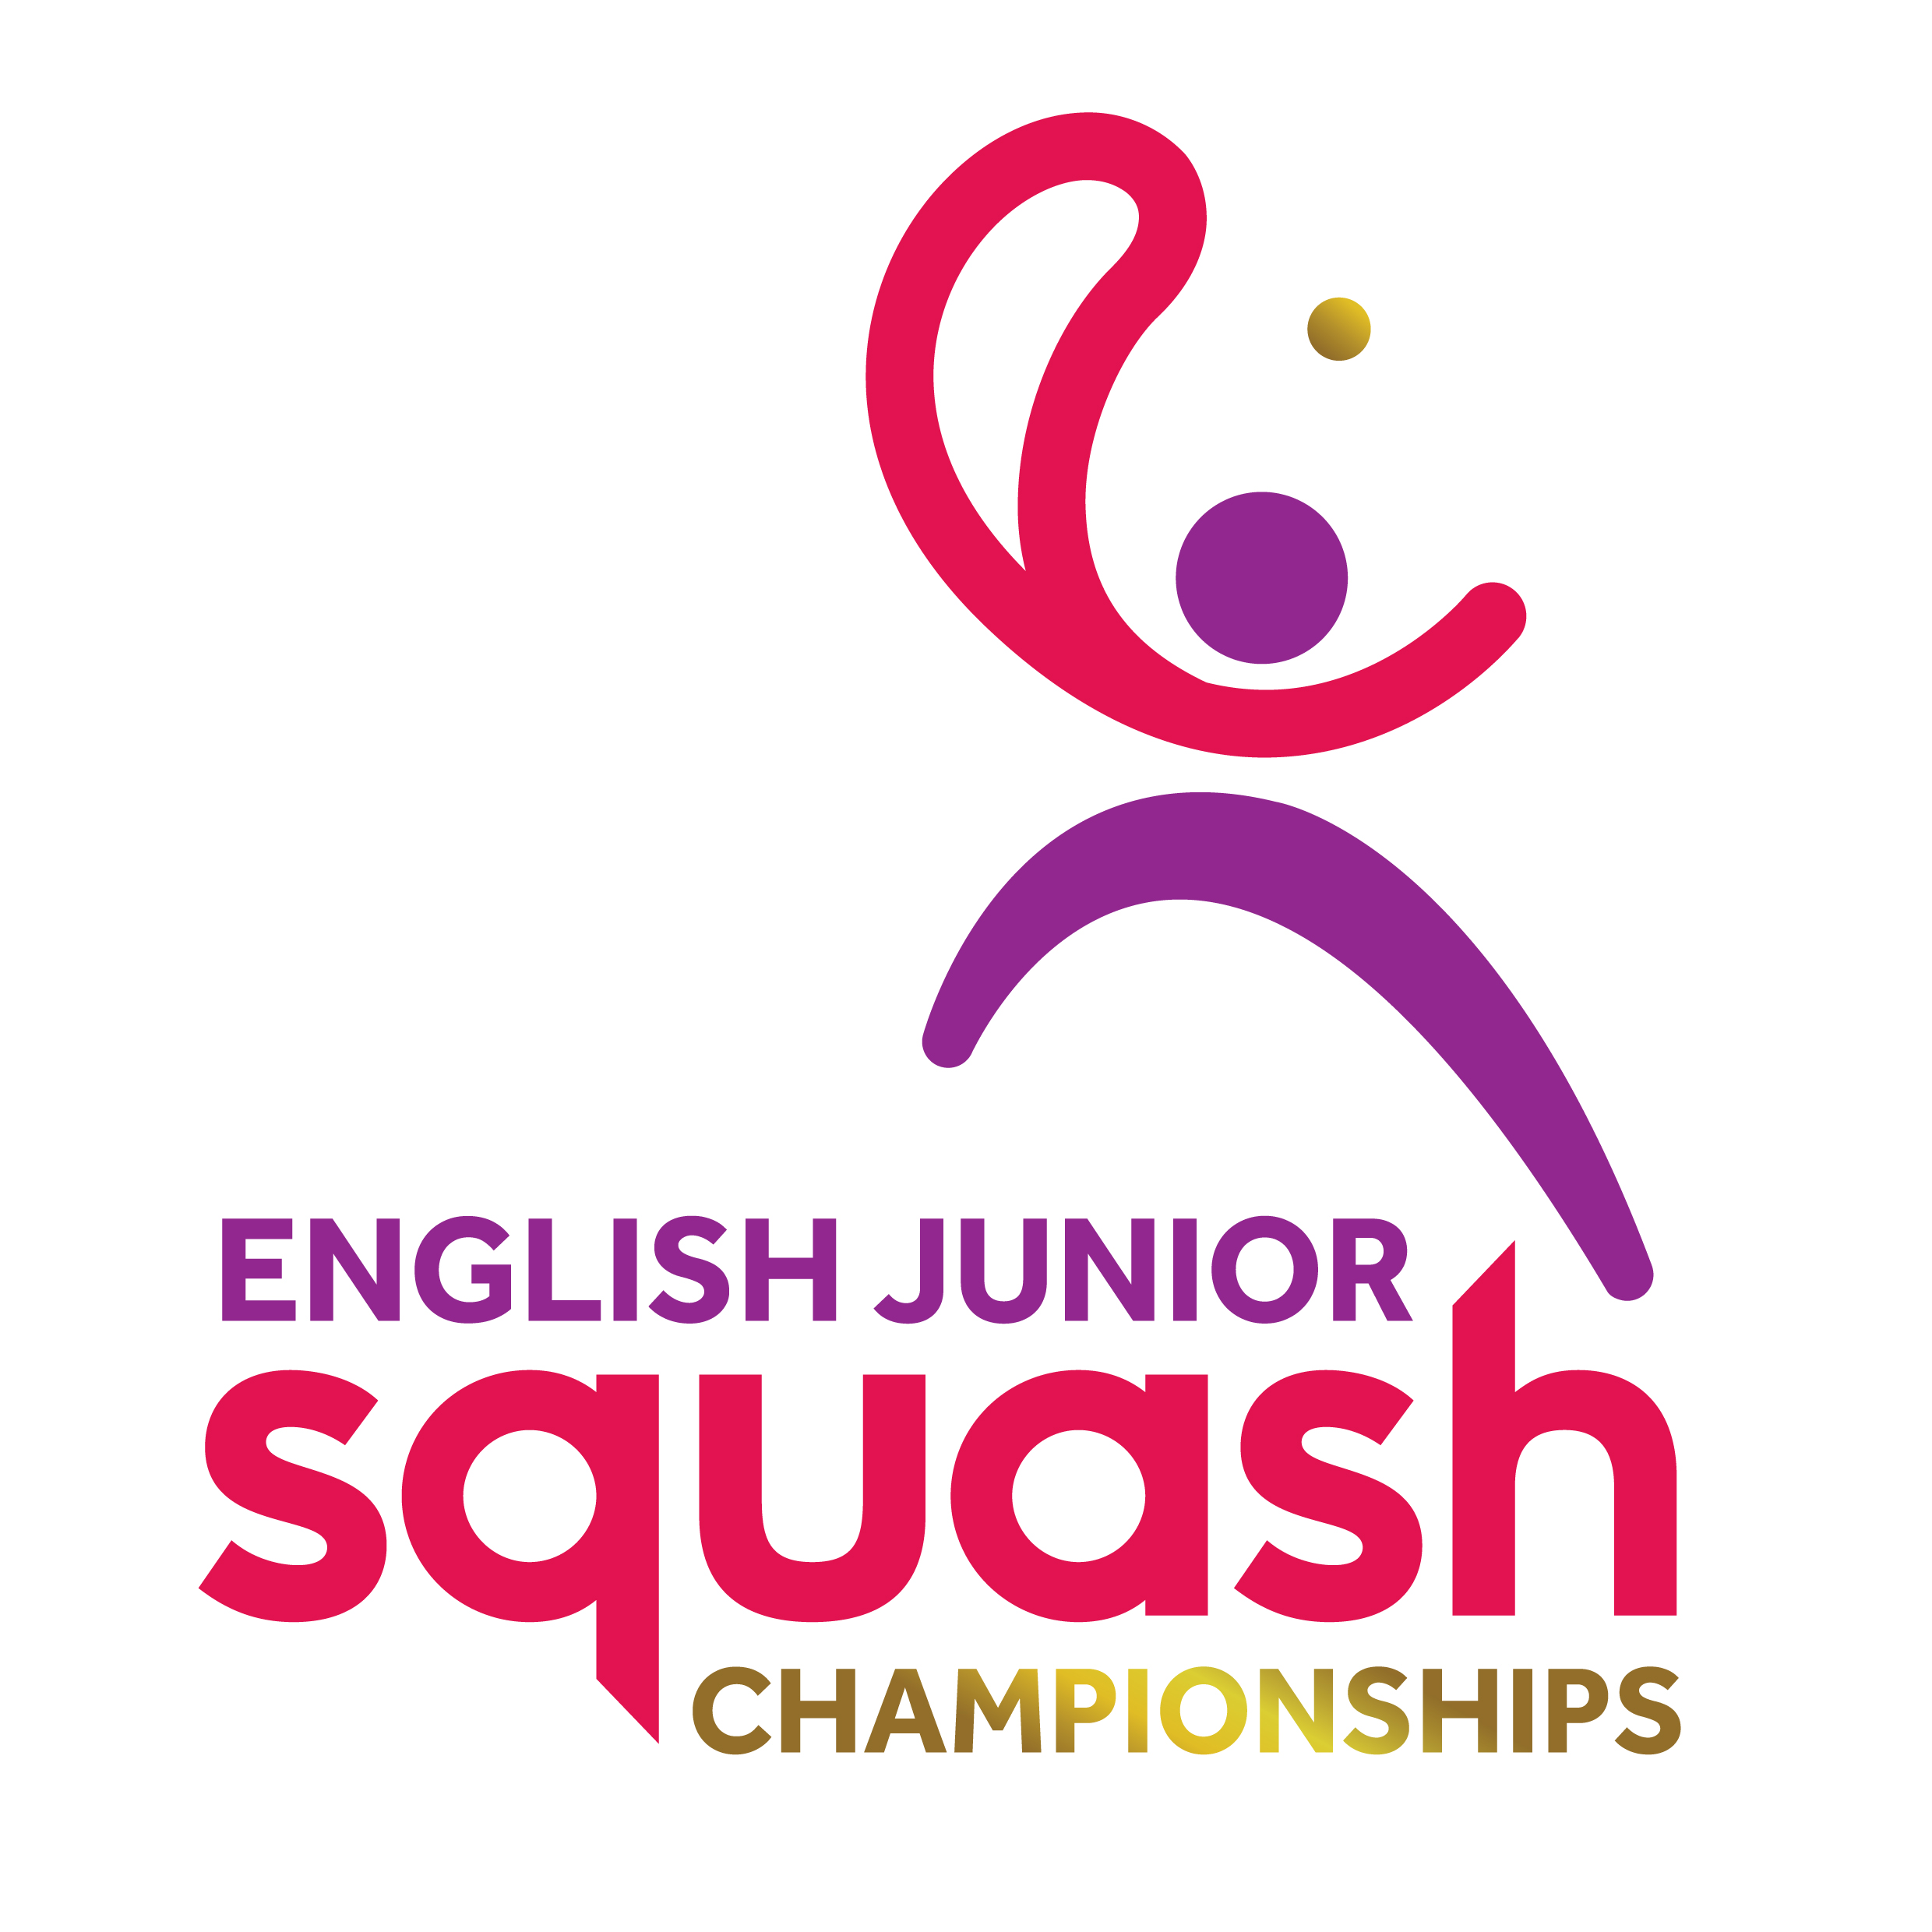

ENGLISH JUNIOR CHAMPIONSHIPS 2017
Round 1 | Q Finals | S Finals | Final
James Averill | Joe Royle 10/12, 11/8, 11/4, 12/10
Joseph Royle

Joe Pannell | Joe Pannell  11/9, 11/5, 6/11, 13/11
Jake Sim-Baskar |  | Joe Pannell  11/7, 11/8, 8/11, 11/6
Luke Perkins | Luke Perkins  11/4, 11/6, 9/11, 11/8
Bailey Malik

Thomas Greengrass | Thomas Greengrass  11/6, 13/11, 7/11, 11/6
James Carman |  | Thomas Greengrass  11/3, 3/11, 11/5, 9/11, 11/5 | Thomas Greengrass  3-0  11/6, 12/10, 11/4
Heston Malik | Alex Mullis  11/7, 13/11, 8/11, 11/7 | Alex Mullis  15/13, 8/11, 11/3, 11/8 | Alex Mullis  3-0  11/9, 11/8, 15/13
Alex Mullis

Oliver Coulcher-Porter | Mehul Chopra  11/6, 11/4, 11/7
Mehul Chopra

Alexander Broadbridge | Louis Murray  11/3, 11/8, 11/8 | Louis Murray  11/7, 11/7, 14/16, 11/7
Louis Murray

Eden Spooner | Tom Miller  12/10, 11/7, 9/11, 11/7
Tom Miller

BOYS UNDER 13 PLATE

Thomas Greengrass
3-2
8/11, 9/11, 11/4, 11/7, 11/4

Thomas Greengrass
3-2
8/11, 9/11, 11/4, 11/7, 11/4

