
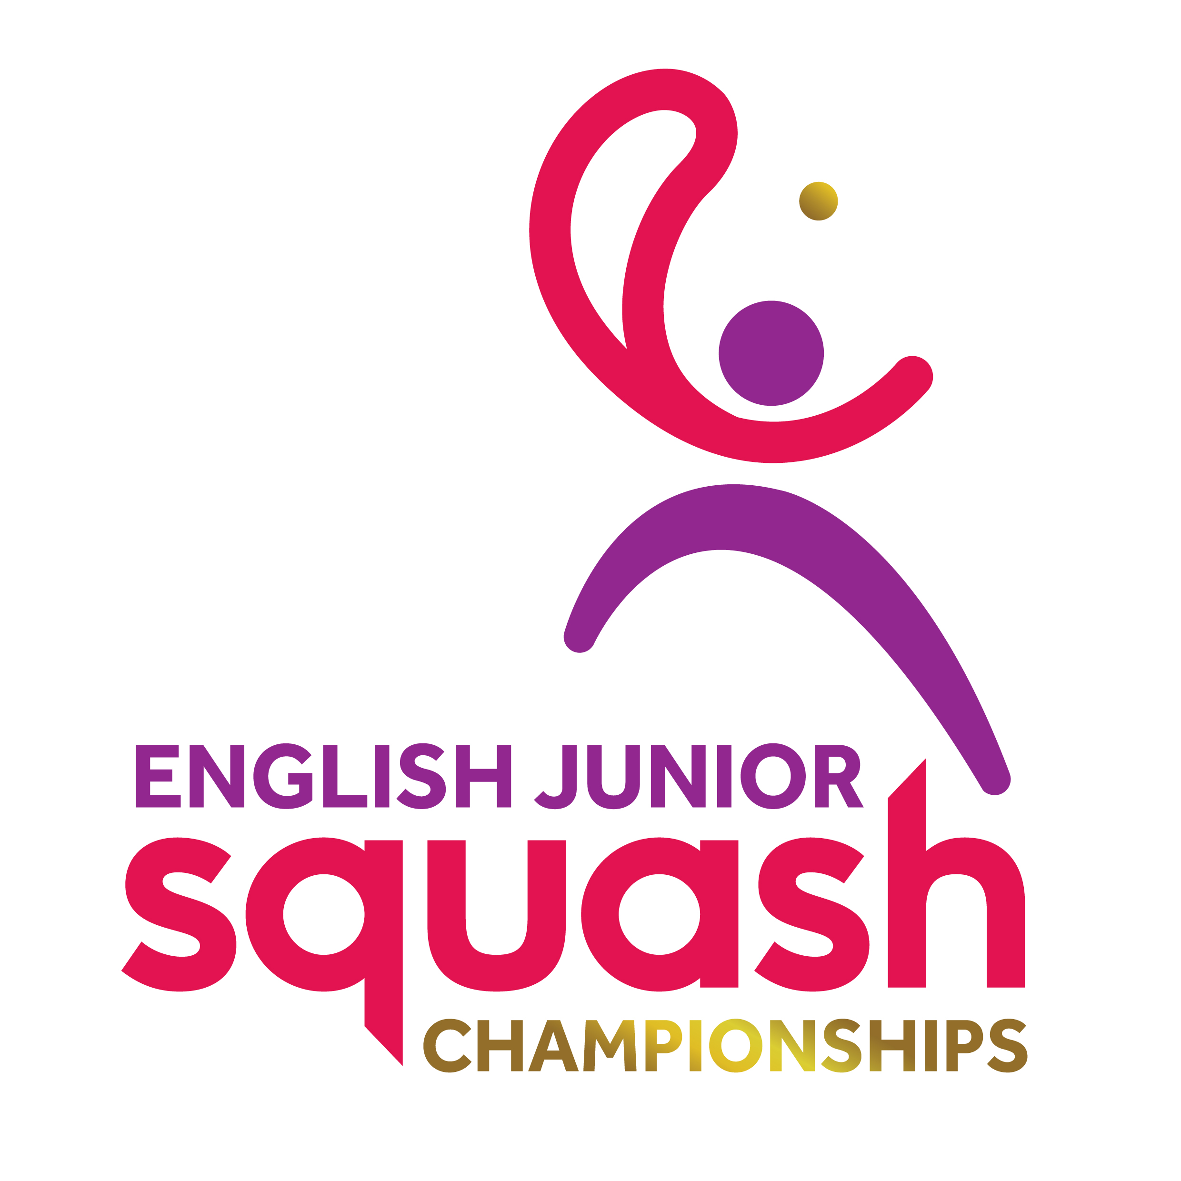

ENGLISH JUNIOR CHAMPIONSHIPS 2017
Round 1 | Q Finals | S Finals | Final
MALIK BILEN | Tymour Saba  11/6, 12/10, 11/4
TYMOUR SABA

TOBY PONTING | Toby Ponting  6/11, 11/4, 11/5, 11/5
LAURENCE CULL |  | Toby Ponting  11/4, 6/11, 5/11, 11/7, 11/7
BEN HARRISON | Ben Harrison  9/11, 9/11, 14/12, 11/3, 11/5
JORDAN STEWART
BEN PERKINS | Luca Campbell Wynter  11/4, 11/2,14/16, 11/5
LUCA CAMPBELL-WYNTER |  | Ben Harrison  14/12, 11/3, 9/11, 11/5 | Ben Harrison  3-2  8/11, 15/13, 11/2, 6/11, 11/9
JAKE WILD | Billy Miles  11/4, 11/5, 11/7 | Billy Miles  11/2, 11/4, 11/5 | Billy Miles  3-0  11/6, 11/4, 11/1
Billy Miles
ZAID MUSHTAQ | Zaid Mushtaq  11/9, 11/13, 8/11, 12/10, 11/4
ETHAN CHAK
Zan Farooqi | Travis Jack Tatum  10/12, 11/6, 8/11, 13/11, 11/8 | Joss Sim-Basker  6/11, 11/9, 11/6, 11/9
TRAVIS-JACK TATUM

GEORGE BIDDER | Joss Sim-Basker  11/9, 11/2, 11/6
Joss Sim-Basker

BOYS UNDER 15 PLATE

Billy Miles 3-0
11/1, 11/6, 11/7

