
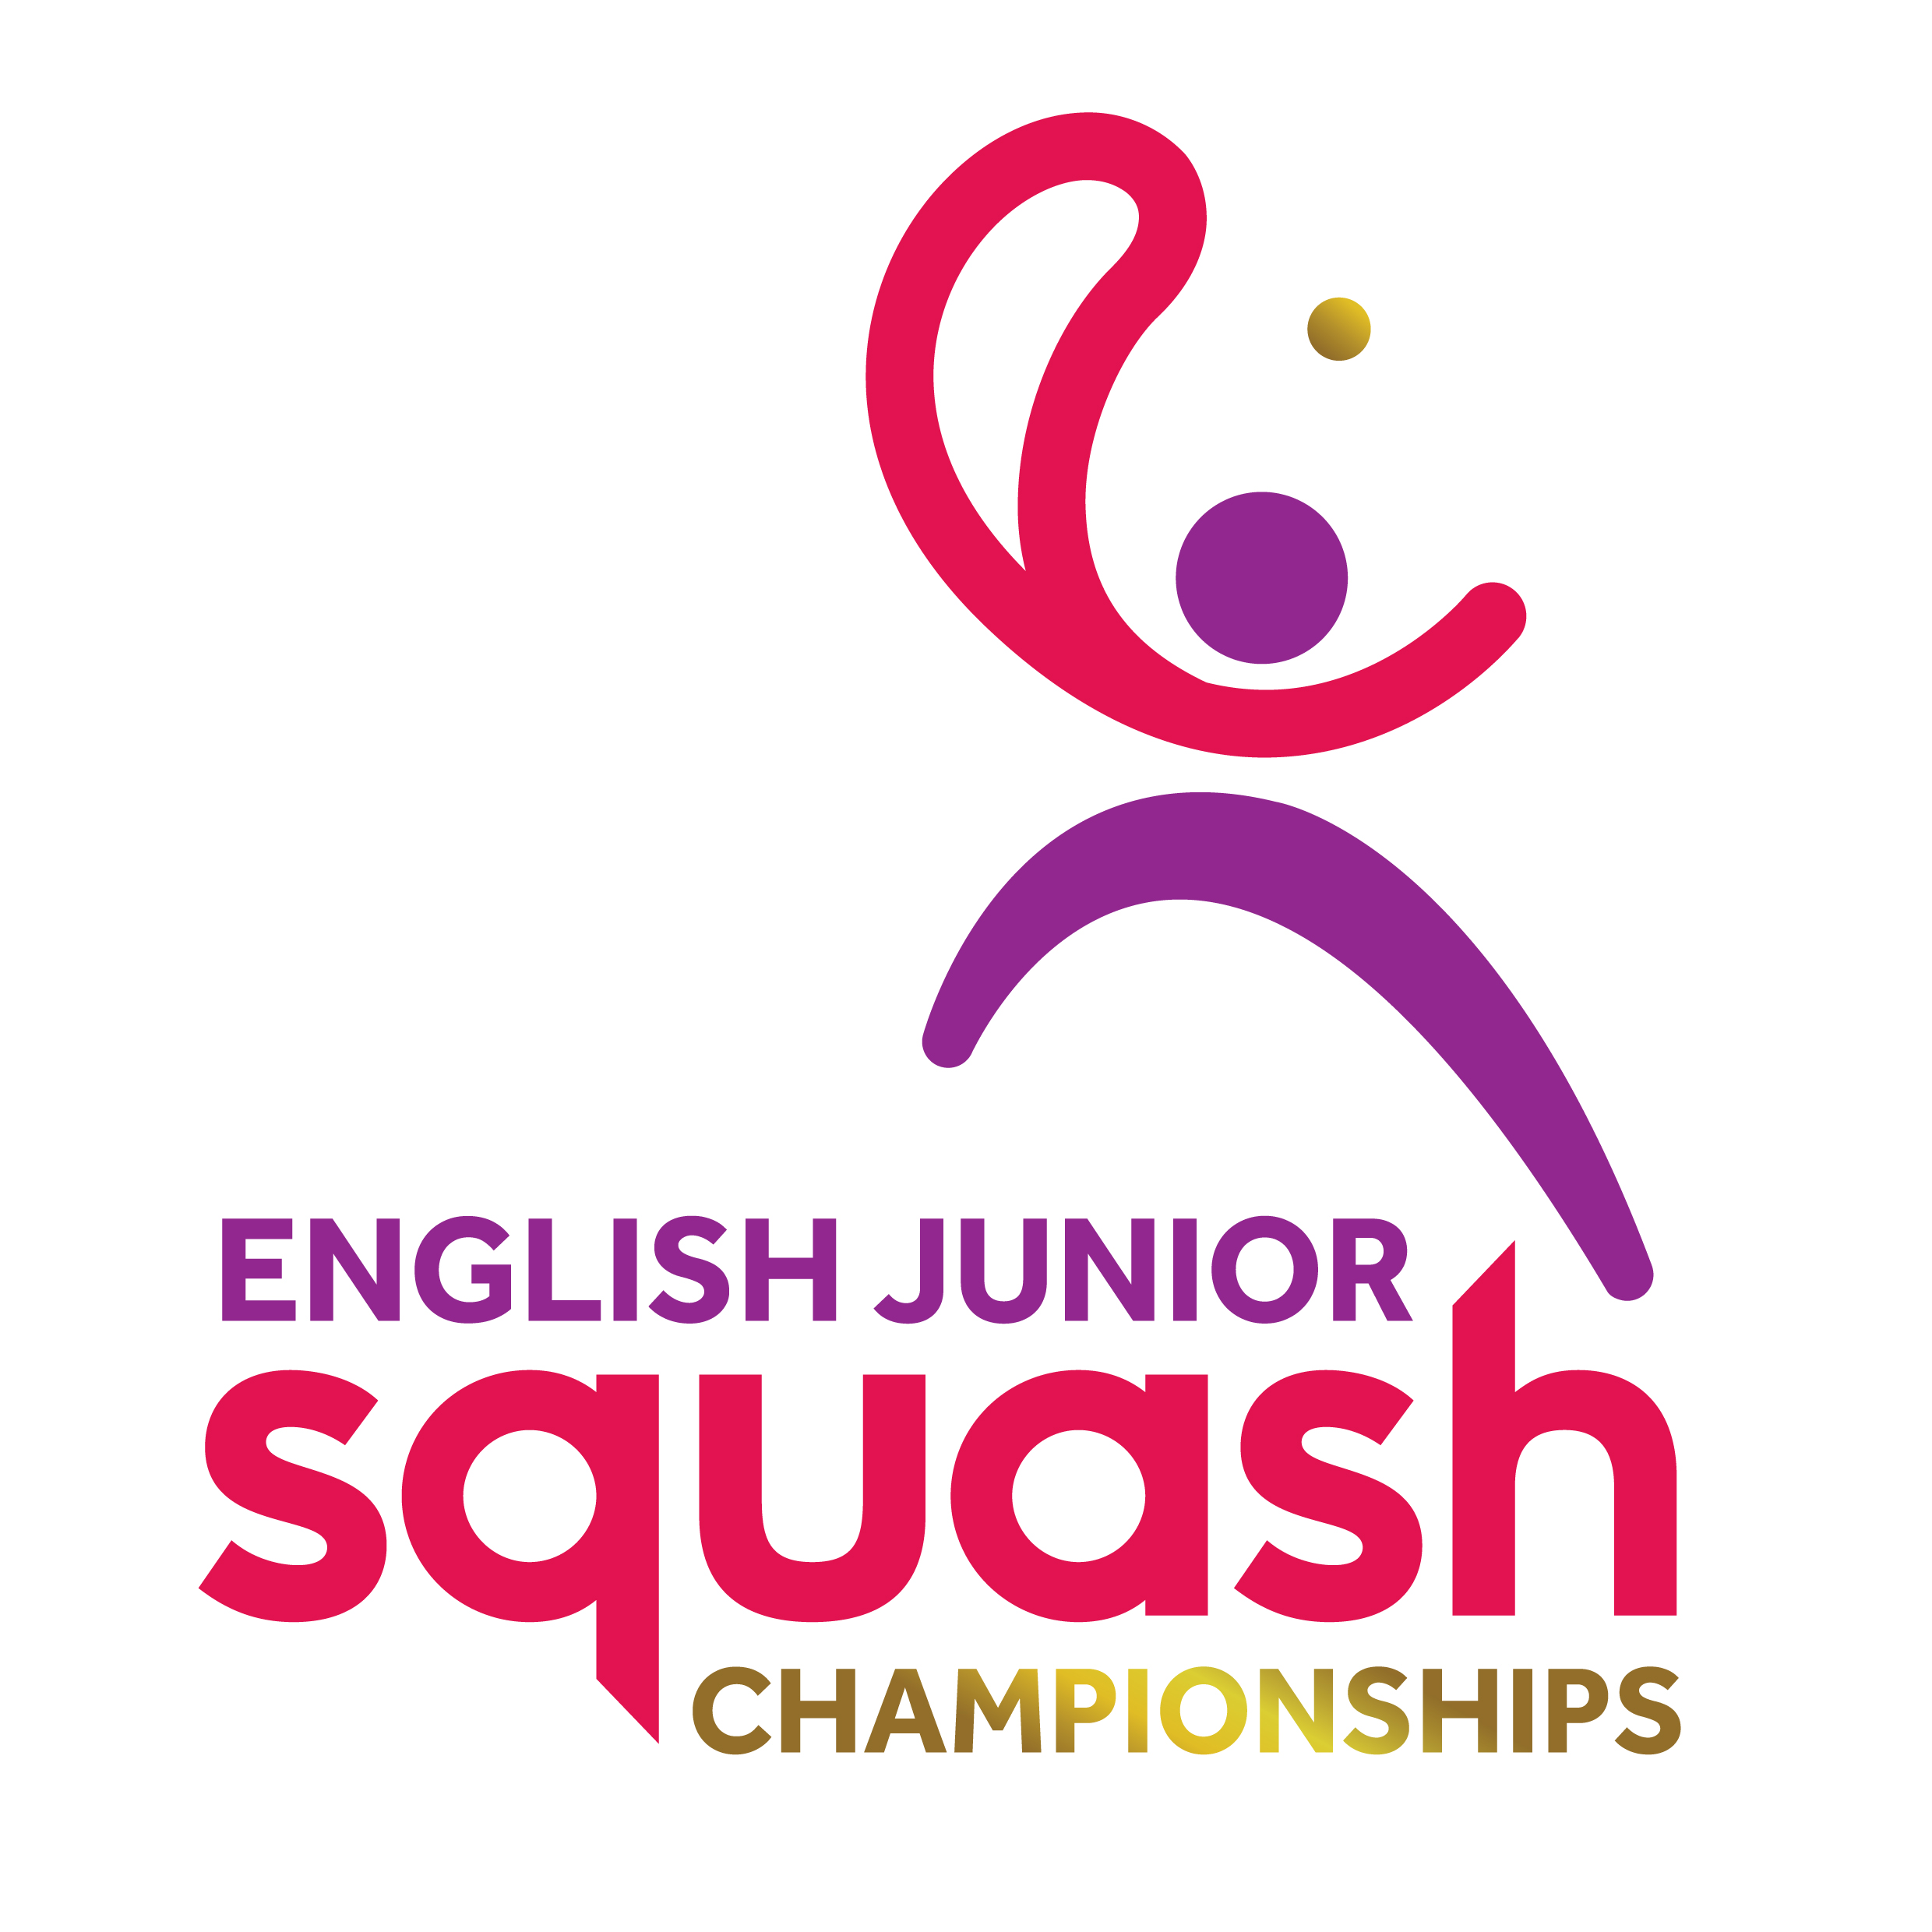

ENGLISH JUNIOR CHAMPIONSHIPS 2017
GIRLS UNDER 15

First Round | Court Time | Results
[1] Lydia Robinson  Amy Royle | FRI 11.40  EPC C1 | Lydia Robinson  11/8, 11/4, 14/12
[9/16] Ellis Miller  Marialena Iacovides | FRI 11.40  EPC C2 | Ellis Miller  3-1 7/11, 11/3, 11/6, 11/5
[9/16] Amy Pullen  Georgina Mullis | FRI11.40  EPC C3 | Amy Pullen  3-0 11/3, 11/3, 11/1
[5/8] Jessica Morgan  Thea Lawton | FRI 11.40  EPC C4 | Jessica Morgan  3-0 11/6, 11/6, 11/1
[5/8] Laura Longfield  Siobhan Wilkins | FRI 11.40  EPC C7 | Laura Longfield  3-0 11/6, 11/4, 11/5
[9/16] Abigail Wilkinson  Tashy Baker | FRI 11.40  EPC C8 | Tashy Baker  3-1 12/10, 11/13, 11/8, 15/13
[9/16] Anje Bryant  Ophelia Watson | FRI 11.40  EPC C9 | Anje Bryant  3-0 11/6, 11/2, 11/3
[3/4] Amber Copley  Ella Hall | FRI 11.40  EPC C10 | Amber Copley  3-0 11/8, 11/4, 11/6
[3/4] Anya Stojanovic  Aliza Sheikh | FRI 13.00  EPC C1 | Anya Stojanovic  3-0 11/6, 11/4, 11/4
[9/16] Libby Leivers  Maddy Hill | FRI 13.00  EPC C2 | Maddy Hill  11/2, 11/7, 5/11, 11/9
[9/16] Saran Nghiem  Harriet Wight | FRI 13.00  EPC C3 | Saran Nghiem  3-0 11/3, 11/7, 11/6
[5/8] Ellie Hewes  Lucy Cox | FRI 13.00  EPC C4 | Ellie Hewes  3-0 11/6, 11/3, 11/5
[5/8] Karishma Bansal  Danni Kalar | FRI 13.00  EPC C7 | Karishma Bansal  3-0 11/5, 11/5, 11/5
[9/16] Olivia Phillips  Anya Shah | FRI 13.00  EPC C8 | Olivia Phillips  3-0 11/5, 11/4, 11/5
[9/16] Megan Evans  Sophia John | FRI 13.00  EPC C9 | Megan Evans  3-0 11/8, 11/3, 11/8
Jodie Dowe  [2] Maia Pannell | FRI 13.00  EPC C10 | Maia Pannell  3-0 11/6, 11/4, 11/2

Second Round  Last 16 | Court  Time | Results

Lydia Robinson | FRI 17.00  EPC C1 | Lydia Robinson  3-0 11/6, 11/9, 11/3
Ellis Miller | FRI 17.00  EPC C1 | Lydia Robinson  3-0 11/6, 11/9, 11/3
Amy Pullen | FRI 17.00  EPC C2 | Jessica Morgan  3-0 11/8, 11/8, 11/2
Jessica Morgan | FRI 17.00  EPC C2 | Jessica Morgan  3-0 11/8, 11/8, 11/2
Laura Longfield | FRI 17.00  EPC C3 | Laura Longfield  3-0 11/6, 11/7, 12/10
Tashy Baker | FRI 17.00  EPC C3 | Laura Longfield  3-0 11/6, 11/7, 12/10
Anje Bryant | FRI 17.00  EPC C4 | Amber Copley  3-2 7/11, 11/8, 11/9, 9/11, 14/12
Amber Copley | FRI 17.00  EPC C4 | Amber Copley  3-2 7/11, 11/8, 11/9, 9/11, 14/12
Anya Stojanovic | FRI 18.20  EPC C1 | Anya Stojanovic  3-1 11/6, 8/11, 11/9, 11/3
Maddy Hill | FRI 18.20  EPC C1 | Anya Stojanovic  3-1 11/6, 8/11, 11/9, 11/3
Saran Nghiem | FRI 18.20  EPC C2 | Saran Nghiem  3-0 12/10, 11/2, 11/4
Ellie Hewes | FRI 18.20  EPC C2 | Saran Nghiem  3-0 12/10, 11/2, 11/4
Karishma Bansal | FRI 18.20  EPC C3 | Karishma Bansal  3-0 11/8, 11/4, 11/9
Olivia Phillips | FRI 18.20  EPC C3 | Karishma Bansal  3-0 11/8, 11/4, 11/9
Megan Evans | FRI 18.20  EPC C4 | Maia Pannell  3-0 11/7, 11/7, 11/7
Maia Pannell | FRI 18.20  EPC C4 | Maia Pannell  3-0 11/7, 11/7, 11/7

Third Round  (2nd round winners competing for places 1 to 8) | Court  Time | Results

Lydia Robinson | Sat 12.10  EPC 7 | Lydia Robinson 3-0  11-5 11-4 11-4
Jessica Morgan | Sat 12.10  EPC 7 | Lydia Robinson 3-0  11-5 11-4 11-4
Laura Longfield | Sat 12.10  EPC 8 | Laura Longfield 3-1  11-2 13-11 7-11 11-9
Amber Copley | Sat 12.10  EPC 8 | Laura Longfield 3-1  11-2 13-11 7-11 11-9
Anya Stojanovic | Sat 12.10  EPC 9 | Saran Nghiem 3-2  8-11 11-8 9-11 11-8 11-3
Saran Nghiem | Sat 12.10  EPC 9 | Saran Nghiem 3-2  8-11 11-8 9-11 11-8 11-3
Karishma Bansal | Sat 12.10  EPC 10 | Maia Pannell 3-1  11-9 11-9 7-11 11-6
Maia Pannell | Sat 12.10  EPC 10 | Maia Pannell 3-1  11-9 11-9 7-11 11-6

Third Round  (2nd round losers competing for places 9 to 16) | Court  Time | Results

Ellis Miller | Sat 09.00  EPC 1 | Amy Pullen 3-1  8-11 11-9 11-4 11-6
Amy Pullen | Sat 09.00  EPC 1 | Amy Pullen 3-1  8-11 11-9 11-4 11-6
Tashy Baker | Sat 09.00  EPC 2 | Anje Bryant 3-0  11-0 11-4 11-2
Anje Bryant | Sat 09.00  EPC 2 | Anje Bryant 3-0  11-0 11-4 11-2
Maddy Hill | Sat 09.00  EPC 3 | Ellie Hewes 3-1  11-7 3-11 11-7 11-4
Ellie Hewes | Sat 09.00  EPC 3 | Ellie Hewes 3-1  11-7 3-11 11-7 11-4
Olivia Phillips | Sat 09.00  EPC 4 | Megan Evans 3-0  11-9 11-7 11-7
Megan Evans | Sat 09.00  EPC 4 | Megan Evans 3-0  11-9 11-7 11-7

Fourth Round  (3rd round winners 1 to 8 competing for places 1 to 4) | Court  Time | Results

Lydia Robinson | Sat 17.40  EPC 3 | Lydia Robinson 3-0  11-9 11-4
Laura Longfield | Sat 17.40  EPC 3 | Lydia Robinson 3-0  11-9 11-4
Saran Nghiem | Sat 17.40  EPC 8 | Maia Pannell 3-0  11-5 11-6 11-8
Maia Pannell | Sat 17.40  EPC 8 | Maia Pannell 3-0  11-5 11-6 11-8

Fourth Round  (3rd round losers 1 to 8 competing for places 5 to 8) | Court  Time | Results

Jessica Morgan | Sat 19.00  EPC 9 | Amber Copley 3-2  9-11 8-11 11-8 11-1 11-7
Amber Copley | Sat 19.00  EPC 9 | Amber Copley 3-2  9-11 8-11 11-8 11-1 11-7
Anya Stojanovic | Sat 19.00  EPC 10 | Anya Stojanovic 3-1  4-11 11-9 11 15-13
Karishma Bansai | Sat 19.00  EPC 10 | Anya Stojanovic 3-1  4-11 11-9 11 15-13

Fourth Round  (3rd round winners 9 to 16 competing for places 9 to 12) | Court  Time | Results

Amy Pullen | Sat 14.40  EPC 9 | Anje Bryant 3-2  9-11 5-11 11-9 11-3 12-10
Anje Bryant | Sat 14.40  EPC 9 | Anje Bryant 3-2  9-11 5-11 11-9 11-3 12-10
Ellie Hewes | Sat 14.40  EPC 10 | Megan Evans 3-1  10-12 11-7 11-9 11-4
Megan Evans | Sat 14.40  EPC 10 | Megan Evans 3-1  10-12 11-7 11-9 11-4

Fourth Round  (3rd round losers 9 to 16 competing for places 13 to 16) | Court  Time | Results

Ellis Miller | Sat 14.40  EPC 7 | Ellis Miller 3-1  11-5 11-7 5-11 11-5
Tashy Baker | Sat 14.40  EPC 7 | Ellis Miller 3-1  11-5 11-7 5-11 11-5
Maddy Hill | Sat 14.40  EPC 8 | Olivia Phillips 3-0  11-7 11-7 11-6
Olivia Phillips | Sat 14.40  EPC 8 | Olivia Phillips 3-0  11-7 11-7 11-6

Court  Time | Final / Play-Offs | Result | Final Position | Final  Place

Sun  13.00  EPC 3 | Lydia Robinson | 3-2  7-11 11-2 9-11 11-9 11-8 | Lydia Robinson | 1
Sun  13.00  EPC 3 | Maia Pannell | 3-2  7-11 11-2 9-11 11-9 11-8 | Maia Pannell | 2
Sun  13.00  EPC 1 | Laura Longfield | 3-1  12-10 11-9 11-13 11-6 | Saran Nghiem | 3
Sun  13.00  EPC 1 | Saran Nghiem | 3-1  12-10 11-9 11-13 11-6 | Laura Longfield | 4
Sun  09.30  EPC 7 | Anya Stojanovic | 3-2  9-11 11-1 9-11 11-8 11-5 | Anya Stojanovic | 5
Sun  09.30  EPC 7 | Amber Copley | 3-2  9-11 11-1 9-11 11-8 11-5 | Amber Copley | 6
Sun  09.30  EPC 8 | Karishma Bansai | 3-0  11-6 15-13 11-8 | Karishma Bansai | 7
Sun  09.30  EPC 8 | Jessica Morgan | 3-0  11-6 15-13 11-8 | Jessica Morgan | 8
Sun  09.30  EPC 9 | Anje Bryant | 3-1  11-7 11-6 5-11 13-11 | Megans Evans | 9
Sun  09.30  EPC 9 | Megan Evans | 3-1  11-7 11-6 5-11 13-11 | Anje Bryant | 10
Sun  09.30  EPC 10 | Amy Pullen | 3-1  5-11 11-5 11-9 11-7 | Ellie Hewes | 11
Sun  09.30  EPC 10 | Ellie Hewes | 3-1  5-11 11-5 11-9 11-7 | Amy Pullen | 12
Sun  10.00  EPC 1 | Ellis Miller | 3-1  11-9 11-9 8-11 11-5 | Ellis Miller | 13
Sun  10.00  EPC 1 | Olivia Phillips | 3-1  11-9 11-9 8-11 11-5 | Olivia Phillips | 14
Sun  10.00  EPC 2 | Tashy Baker | 3-0  11-7 11-7 11-9 | Maddy Hill | 15
Sun  10.00  EPC 2 | Maddy Hill | 3-0  11-7 11-7 11-9 | Tashy Baker | 16

