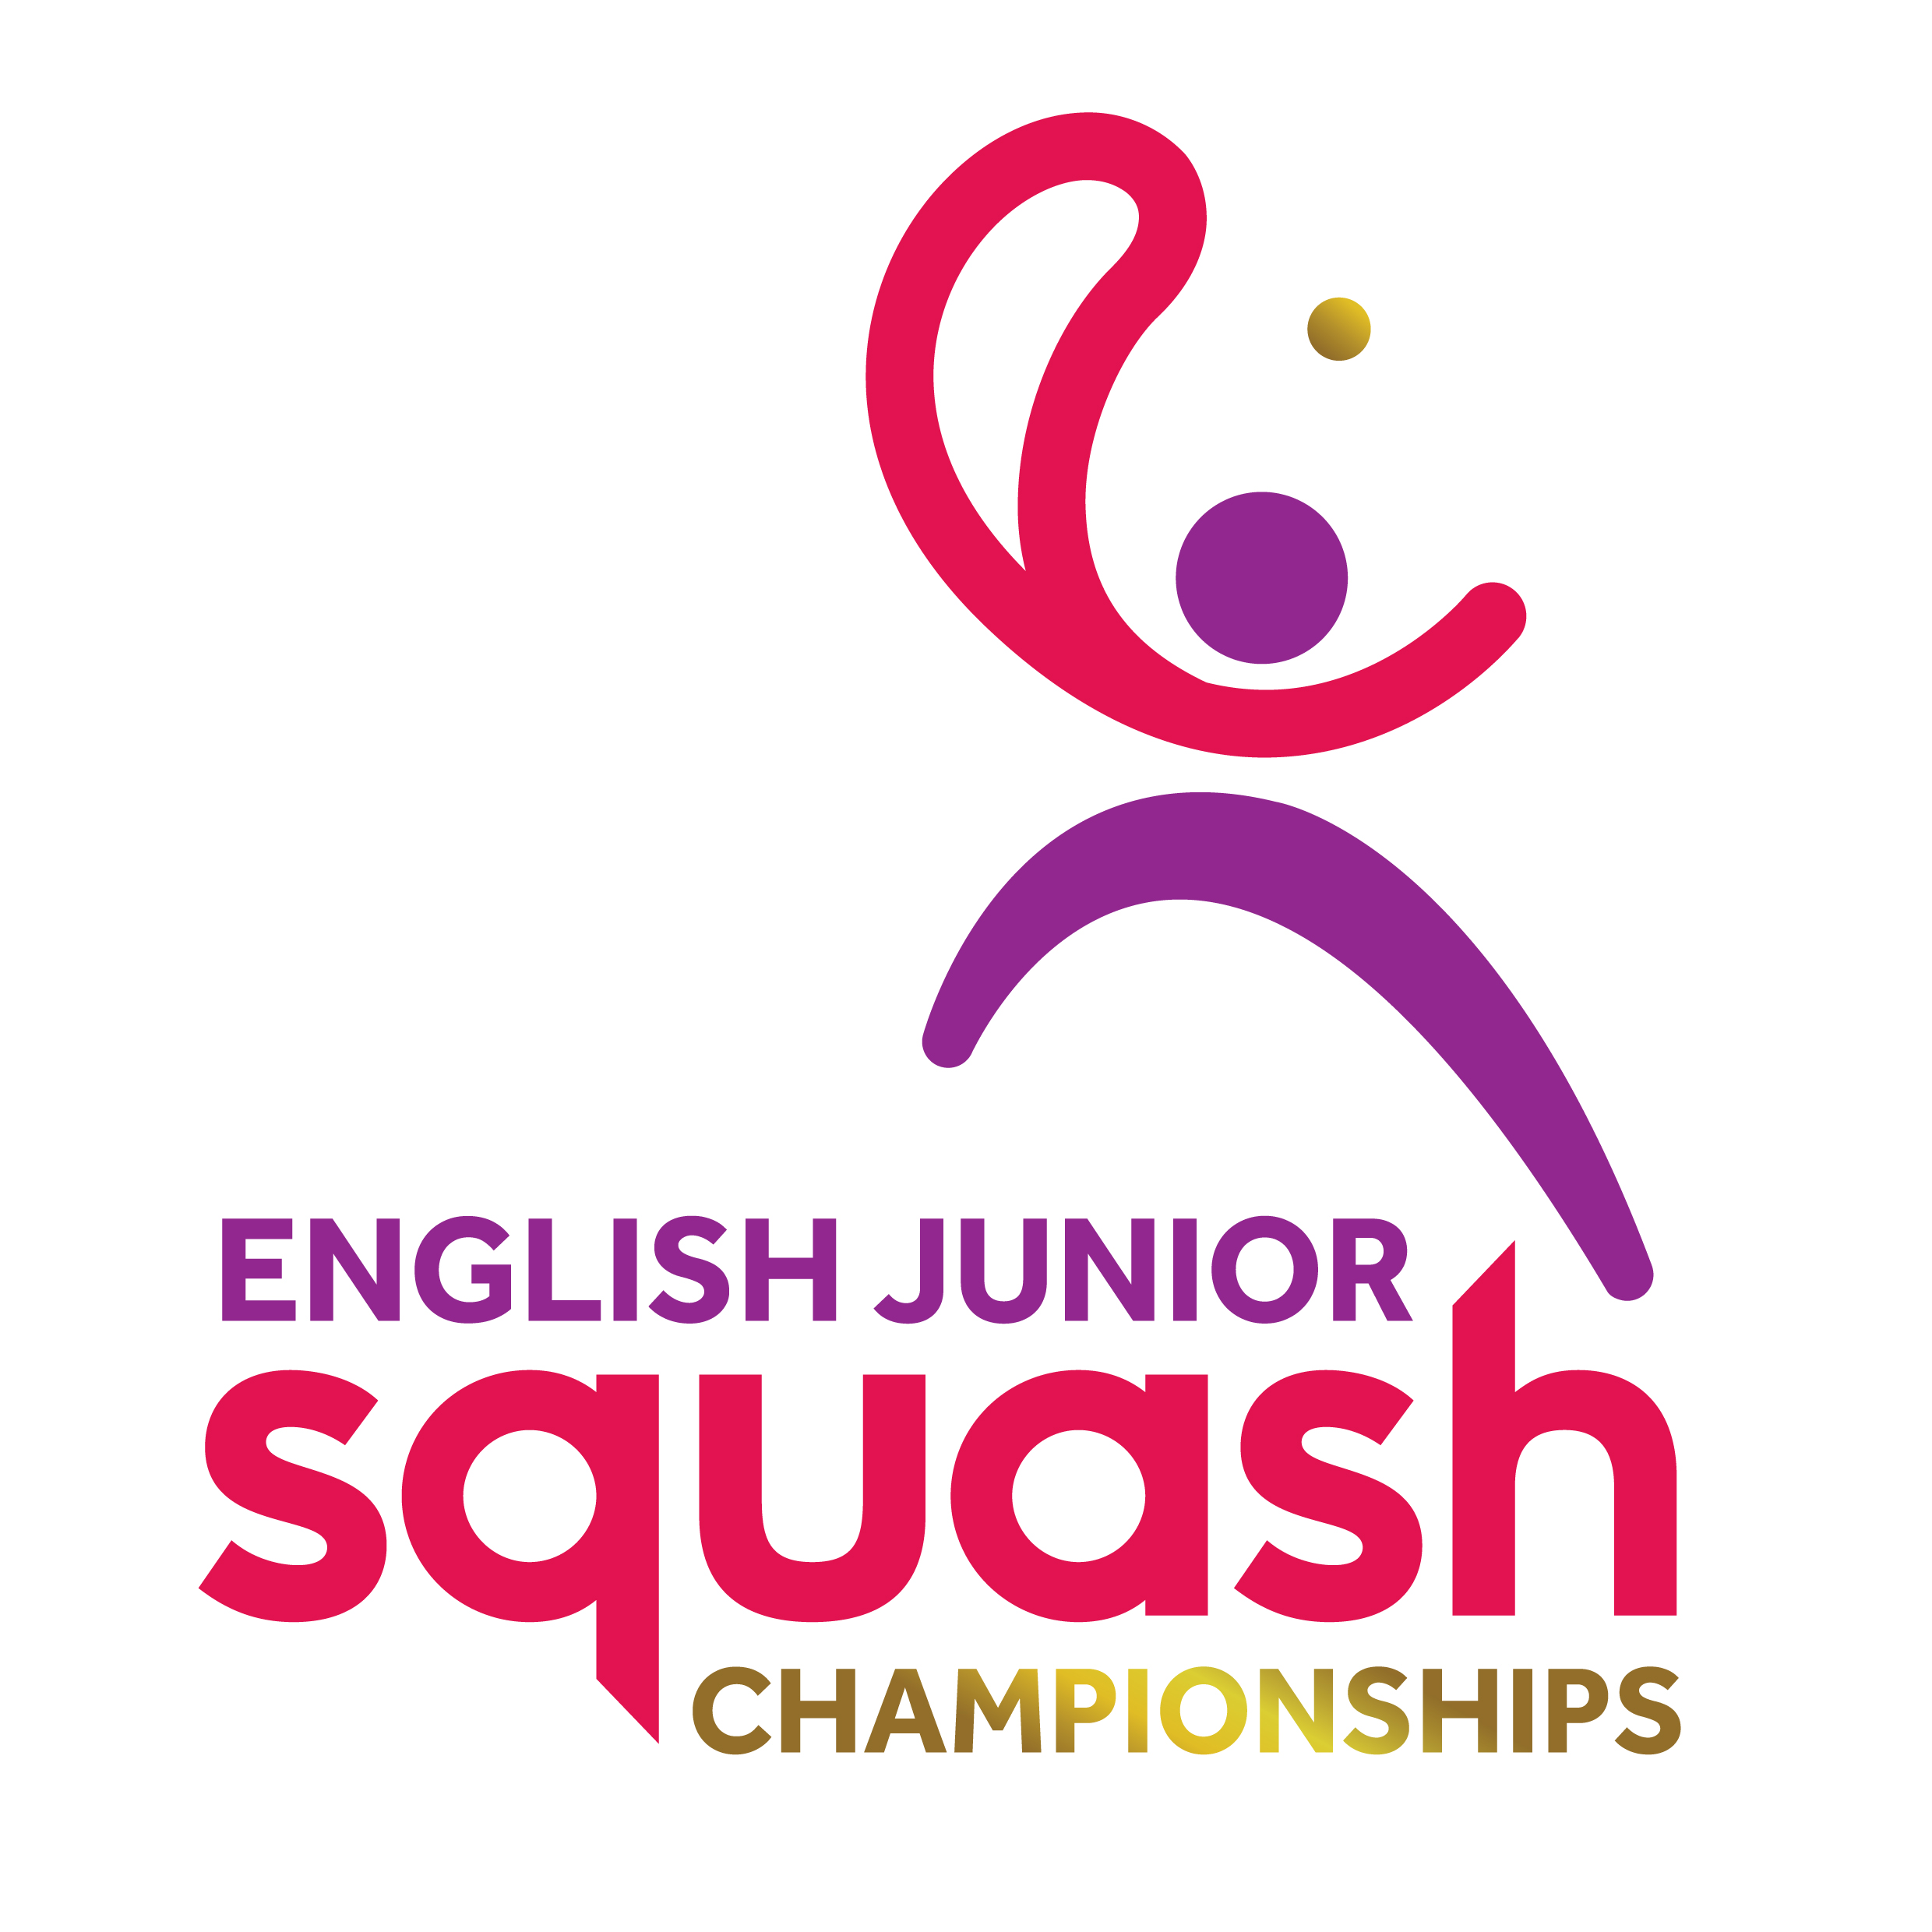


ENGLISH JUNIOR CHAMPIONSHIPS 2017
BOYS UNDER 17

First Round | Court Time | Results
[1] Oscar Beach  Karim Samir | FRI 13.00  UOB C1 | O. Beach 3-0 11-5 11-3 11-6
[9/16] Daniel Wells  Luke Credland | FRI 13.00  UOB C2 | D. Wells 3-2 10-12 11-2 2-11 11-7 11-8
[9/16] Samuel Hay  Noah Meredith | FRI 13.00  UOB C3 | S. Hay 3-0 11-2 11-4 11-4
[5/8] Lewis Anderson  Edward Wheeler | FRI 13.00  UOB C4 | L. Anderson 3-0 11-8 11-7 11-3
[5/8] Benjamin Cross  Millen Randell | FRI 13.00  UOB C5 | B. Cross 3-1 14-12 6-11 12-10 11-6
[9/16] Keane Appleton  Simon Herbert | FRI 13.00  UOB C6 | K. Appleton 3-2 12-10 4-11 8-11 11-3 11-7
[9/16] Perry Malik  Max Forster | FRI 14.20  UOB C3 | P. Malik 3-0 11-5 11-4 11-4
[3/4] Julian Standish  Lochlan Walshe | FRI 14.20  UOB C4 | J. Standish 3-1 11-7 11-3 10-12 12-10
[3/4] Richard Hall  Louie Martin | FRI 14.20  UOB C5 | R. Hall 3-1 11-7 11-3 2-11 11-5
[9/16] Jack Mitterer  Andrew Shipley | FRI 14.20  UOB C6 | J. Mitterer 3-0 11-3 11-7 11-8
Ed Miles  Daniel Haggarty | FRI 15.00  UOB C1 | Ed Miles 3-2 11-6 11-7 9-11 7-11 11-7
[5/8] Jared Carter  Marcus Connor | FRI 15.00  UOB C2 | J. Carter 3-0 11-2 11-5 11-8
[5/8] Jack Turvey  Oscar Khoo | FRI 15.00  UOB C3 | J. Turvey 3-1 11-2 12-10 5-11 11-9
[9/16] Harry Anderson  Joshua Leahy | FRI 15.00  UOB C4 | H. Anderson 11-5 11-13 11-3 11-1
[9/16] Panos Liatis  Harry Kitchens | FRI 15.00  UOB C5 | P. Liatis 3-0 11-8 14-12 11-4
Abdul Muqaddam Khan  [2] Benjamin Sockett | FRI 15.00  UOB C6 | B.Sockett 11-5 11-4 3

Second Round  Last 16 | Court  Time | Results

Oscar Beach | FRI 19.00  EPC C1 | Oscar Beach  3-0 11/8, 11/8, 11/4
Daniel Wells | FRI 19.00  EPC C1 | Oscar Beach  3-0 11/8, 11/8, 11/4
Samuel Hay | FRI 19.00  EPC C2 | Lewis Anderson  3-1 11/9, 6/11, 11/8, 11
Lewis Anderson | FRI 19.00  EPC C2 | Lewis Anderson  3-1 11/9, 6/11, 11/8, 11
Ben Cross | FRI 19.00  EPC C3 | Ben Cross  3-0 11/4, 11/9, 11/9
Keane Appleton | FRI 19.00  EPC C3 | Ben Cross  3-0 11/4, 11/9, 11/9
Perry Malik | FRI 19.00  EPC C4 | Perry Malik  3-1 3/11, 11/9, 11/9, 11/7
Julian Standish | FRI 19.00  EPC C4 | Perry Malik  3-1 3/11, 11/9, 11/9, 11/7
Richard Hall | FRI 19.00  EPC C7 | Jack Mitterer  3-0 11/6, 12/10, 11/3
Jack Mitterer | FRI 19.00  EPC C7 | Jack Mitterer  3-0 11/6, 12/10, 11/3
Ed Miles | FRI 19.00  EPC C8 | Jared Carter  3-0 11/6, 11/6, 11/5
Jared Carter | FRI 19.00  EPC C8 | Jared Carter  3-0 11/6, 11/6, 11/5
Jack Turvey | FRI 19.00  EPC C9 | Jack Turvey  3-0 11/2, 11/9, 11/4
Harry Anderson | FRI 19.00  EPC C9 | Jack Turvey  3-0 11/2, 11/9, 11/4
Panos Liatis | FRI 19.00  EPC C10 | Ben Sockett  3-1 11/8, 3/11, 11/3, 11/9
Ben Sockett | FRI 19.00  EPC C10 | Ben Sockett  3-1 11/8, 3/11, 11/3, 11/9

Third Round  (2nd round winners competing for places 1 to 8) | Court  Time | Results

Oscar Beach | Sat 12.50  EPC7 | Lewis Anderson 3-1  11-8 11-3 9-11 11-3
Lewis Anderson | Sat 12.50  EPC7 | Lewis Anderson 3-1  11-8 11-3 9-11 11-3
Ben Cross | Sat 12.50  EPC8 | Ben Cross 3-0  12-10 11-9 11-3
Perry Malik | Sat 12.50  EPC8 | Ben Cross 3-0  12-10 11-9 11-3
Jack Mitterer | Sat 12.50  EPC9 | Jared Carter 3-0  11-7 11-7 13-11
Jared Carter | Sat 12.50  EPC9 | Jared Carter 3-0  11-7 11-7 13-11
Jack Turvey | Sat 12.50  EPC10 | Ben Sockett 3-1  11-4 12-10 11-3 11-7
Ben Sockett | Sat 12.50  EPC10 | Ben Sockett 3-1  11-4 12-10 11-3 11-7

Third Round  (2nd round losers competing for places 9 to 16) | Court  Time | Results

Daniel Wells | Sat 10.30  EPC1 | Samuel Hay 3-1  11-6 9-11 11-7 12-10
Samuel Hay | Sat 10.30  EPC1 | Samuel Hay 3-1  11-6 9-11 11-7 12-10
Keane Appleton | Sat 10.30  EPC2 | Keane Appleton 3-2  8-11 11-8 7-11 11-5 15-13
Julian Standish | Sat 10.30  EPC2 | Keane Appleton 3-2  8-11 11-8 7-11 11-5 15-13
Richard Hall | Sat 10.30  EPC3 | Richard Hall 3-2  9-11 11-6 9-11 11-7 11-9
Ed Miles | Sat 10.30  EPC3 | Richard Hall 3-2  9-11 11-6 9-11 11-7 11-9
Harry Anderson | Sat 10.30  EPC4 | Harry Anderson 3-2  11-7 6-11 11-4 10-12 11-8
Panos Liatis | Sat 10.30  EPC4 | Harry Anderson 3-2  11-7 6-11 11-4 10-12 11-8

Fourth Round  (3rd round winners 1 to 8 competing for places 1 to 4) | Court  Time | Results

Lewis Anderson | Sat 18.20  EPC2 | Lewis Anderson 3-1  9-11 11-4 11-9 11-2
Ben Cross | Sat 18.20  EPC2 | Lewis Anderson 3-1  9-11 11-4 11-9 11-2
Jared Carter | Sat 19.00  EPC 3 | Jared Carter 3-0  11-3 11-8 11-9
Ben Socket | Sat 19.00  EPC 3 | Jared Carter 3-0  11-3 11-8 11-9

Fourth Round  (3rd round losers 1 to 8 competing for places 5 to 8) | Court  Time | Results

Oscar Beach | Sat 19.40  EPC9 | Oscar Beach 3-0  11-9 11-4 11-9
Perry Malik | Sat 19.40  EPC9 | Oscar Beach 3-0  11-9 11-4 11-9
Jack Mitterer | Sat 19.40  EPC10 | Jack Mitterer 3-0  11-8 11-5 11-7
Jack Turvey | Sat 19.40  EPC10 | Jack Mitterer 3-0  11-8 11-5 11-7

Fourth Round  (3rd round winners 9 to 16 competing for places 9 to 12) | Court  Time | Results

Samuel Hay | Sat 15.50  EPC7 | Samuel Hay 3-0  11-8 11-6 11-8
Keane Appleton | Sat 15.50  EPC7 | Samuel Hay 3-0  11-8 11-6 11-8
Richard Hall | Sat 15.50  EPC 8 | Harry Anderson 3-1  11-7 11-6 15-13 14-12
Harry Anderson | Sat 15.50  EPC 8 | Harry Anderson 3-1  11-7 11-6 15-13 14-12

Fourth Round  (3rd round losers 9 to 16 competing for places 13 to 16) | Court  Time | Results

Daniel Wells | Sat 15.50  EPC 9 | Daniel Wells 3-0  15-13 14-12 11-6
Julian Standish | Sat 15.50  EPC 9 | Daniel Wells 3-0  15-13 14-12 11-6
Ed Miles | Sat 15.50  EPC 10 | Ed Miles 3-1  11-7 4-11 11-2 11-9
Panos Liatis | Sat 15.50  EPC 10 | Ed Miles 3-1  11-7 4-11 11-2 11-9

Court  Time | Final / Play-Offs | Result | Final Position | Final  Place

Sun 13.40  EPC 2 | Lewis Anderson | 3-2  11-8 10-12 11-6 9-11 11-7 | Jared Carter | 1
Sun 13.40  EPC 2 | Jared Carter | 3-2  11-8 10-12 11-6 9-11 11-7 | Lewis Anderson | 2
Sun 13.40  EPC 4 | Ben Cross | 3-0  14-12 11-3 11-8 | Ben Socket | 3
Sun 13.40  EPC 4 | Ben Socket | 3-0  14-12 11-3 11-8 | Ben Cross | 4
Sun 10.40  EPC 9 | Oscar Beach | 3-0  11-3 11-8 11-8 | Oscar Beach | 5
Sun 10.40  EPC 9 | Jack Mitterer | 3-0  11-3 11-8 11-8 | Jack Mitterer | 6
Sun 10.40  EPC 10 | Perry Malik | 3-0  11-5 11-2 RTD | Jack Turvey | 7
Sun 10.40  EPC 10 | Jack Turvey | 3-0  11-5 11-2 RTD | Perry Malik | 8
Sun 11.40  EPC 1 | Samuel Hay | 3-1  8-11 11-5 11-3 11-6 | Sam Hay | 9
Sun 11.40  EPC 1 | Harry Anderson | 3-1  8-11 11-5 11-3 11-6 | Harry Anderson | 10
Sun 11.40  EPC 2 | Keane Appleton | 3-2  9-11 7-11 11-9 11-5 11-5 | Keane Appleton | 11
Sun 11.40  EPC 2 | Richard Hall | 3-2  9-11 7-11 11-9 11-5 11-5 | Richard Hall | 12
Sun 11.40  EPC 3 | Ed Miles | 3-0  11-5 11-7 11-7 | Daniel Wells | 13
Sun 11.40  EPC 3 | Daniel Wells | 3-0  11-5 11-7 11-7 | Ed Miles | 14
 | Julian Standish | W/O | Panos Liatis | 15
 | Panos Liatis | W/O | Julian Standish | 16

