
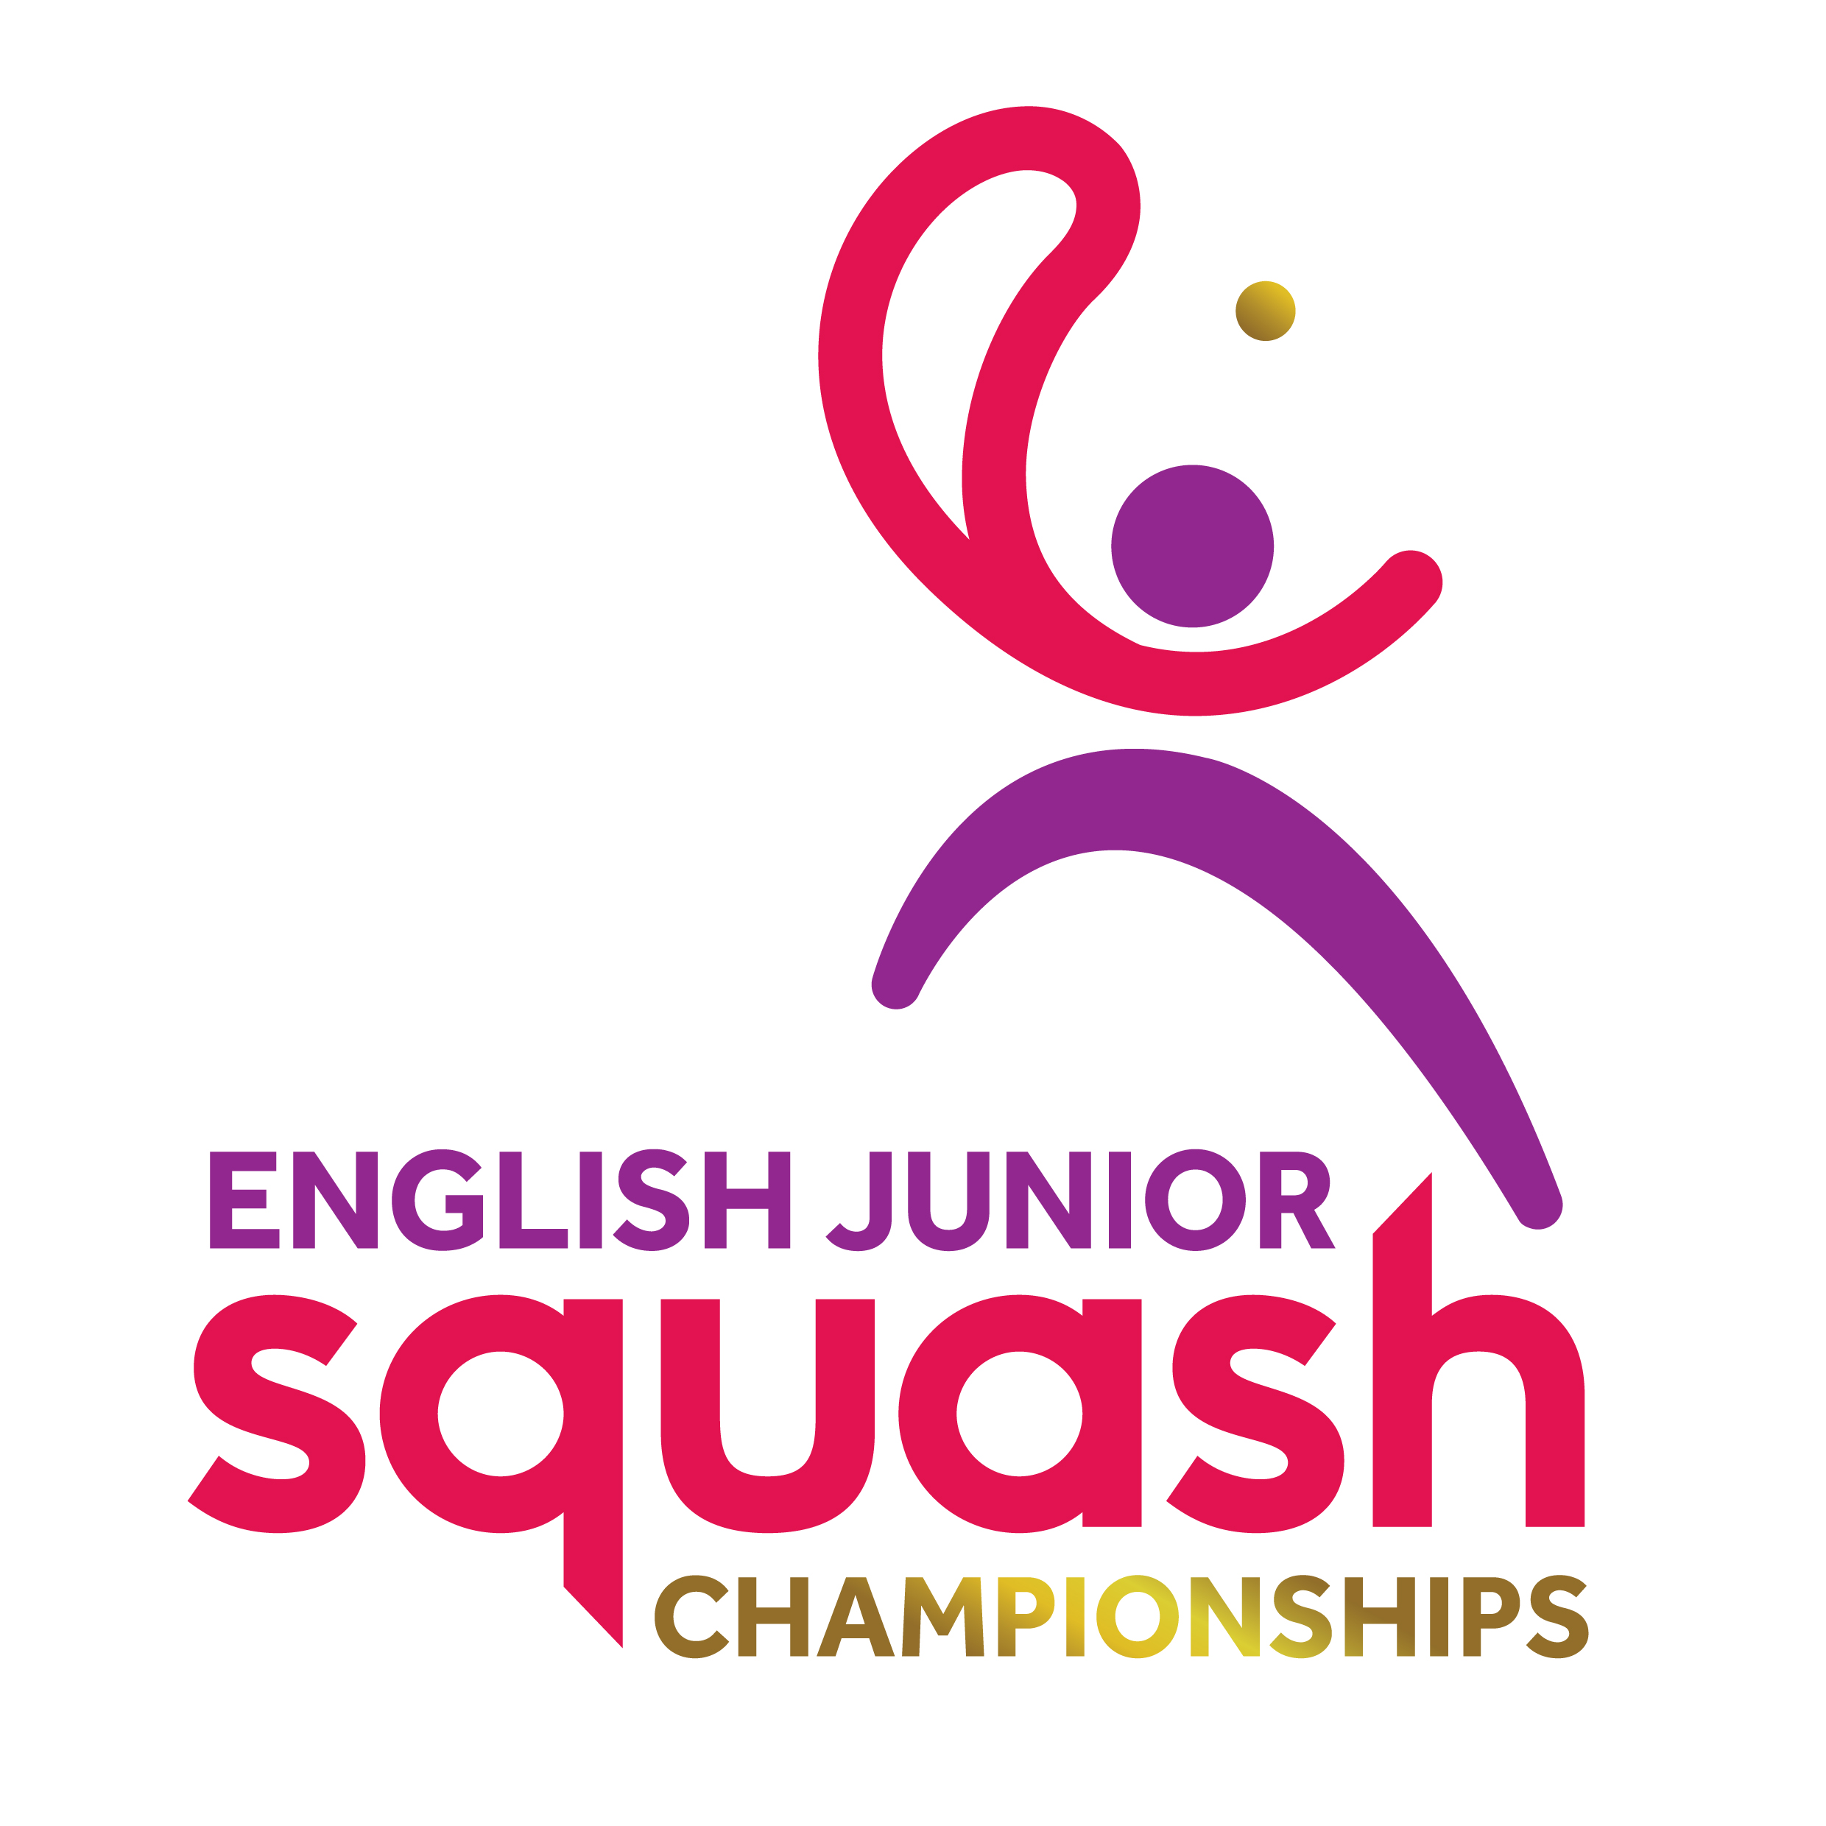

ENGLISH JUNIOR CHAMPIONSHIPS 2017
Round 1 | Q Finals | S Finals | Final
Karim Samir | Luke Credland 3-0
Luke Credland | 11-2 11-3 11-7
Noah Meredith | Noah Meredith 3-0
Edward Wheeler | 11-8 11-8 11-3 | Luke Credland  12/10, 11/6, 12/10
Millen Randell | Simon Herbert
Simon Herbert | W/O
Max Forster | Max Forster 3-0
Lochlan Walshe | 12-10 11-3 11-4 | Max Forster  12/10, 11/4, 13/11 | Max Forster  11/7, 7/11, 13/11, 11/4
Louie Martin | Louie Martin 3-0 | Marcus Connor  12/10, 11/8, 11/5 | Marcus Connor  11/8, 8/11, 11/5, 3/11, 11/7
Andrew Shipley | 11-6 11-9 11-7
Dan Haggarty | Marcus Connor 3-0
Marcus Connor | 11-2 14-12 11-7
Oscar Khoo | Joshua Leahy 3-1 | Abdul Muqaddam Khan  10/12, 12/10, 12/10, 16/14
Joshua Leahy | 7-11 13-11 12-10 11-6
Harry Kitchens | Abdul Muqaddam Khan 3-1
Abdul Muqaddam Khan | 11-9 11-9 9-11 13-11

BOYS UNDER 17 PLATE

Max Forster won
3-0
11/5, 11/4, 11/2

