
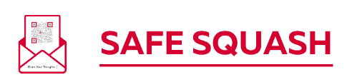
Safeguarding Checklist for Squash Clubs

A Club Welfare Officer has been appointed ☐
The Club Welfare Officer has a valid DBS certificate ☐
The Club Welfare Officer has completed safeguarding training ☐
The Club Welfare Officer’s contact details are displayed at the club ☐
The Club Welfare Officer’s contact details are on the club website ☐
The County Welfare Officer’s contact details are displayed at the club ☐
The County Welfare Officer’s contact details are on the club website ☐
The club has adopted the England Squash Safeguarding Policies ☐
There are links to Safeguarding Policies on the club website ☐
There are links to the England Squash Log of Concern on the club website ☐
All coaches have a valid DBS certificate ☐
All coaches have completed safeguarding training ☐
All coaches have completed First Aid training ☐
Posters around the club reinforce the Code of Conduct ☐
Has a named person on the committee who will champion safeguarding ☐
Posters are visible explaining changing room arrangements ☐
The club has contacted their local Active Partnership Sport Welfare Officer ☐

