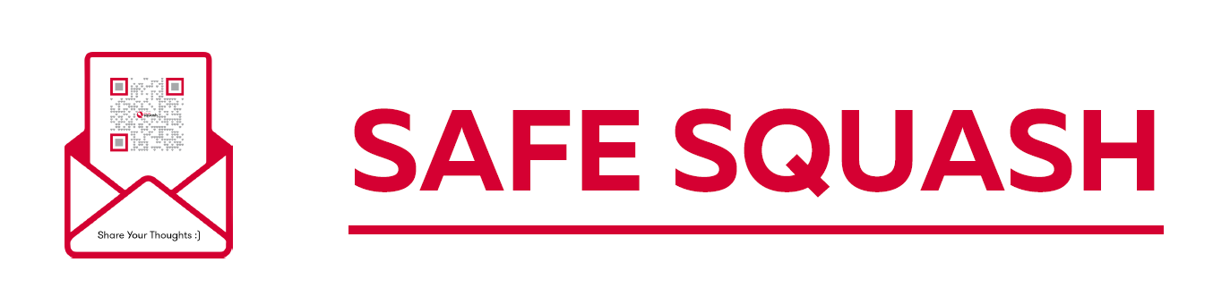

IF YOU HAVE ANY CONCERNS ABOUT YOUR SAFETY OR ARE CONCERNED ABOUT ANYONE ELSE WHILE YOU ARE AT THIS CLUB, YOU CAN TALK TO THE CLUB WELFARE OFFICER
CLUB WELFARE OFFICER:
ADD NAME HERE
TEL NO:
ADD NO HERE
EMAIL:
EMAIL HERE

ADD PHOTO HERE

YOU CAN ALSO CONTACT YOUR COUNTY WELFARE OFFICER:
NAME:

TEL NO:
EMAIL:

