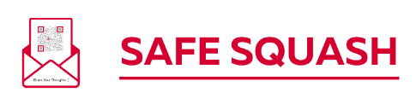
Registration and Consent Form - Template
Confidentiality: Details on this form will be held securely and will only be shared with coaches or others who need this information in order to meet the specific needs of your child.

Personal information – child / young person
Name (and preferred name)
Address
Date of birth and school year
Gender | Male | Female | Non-binary | Another description (please state)
What is your first language or preferred type of communication?
Are there specific things we need to bear in mind to support you?
Are there any activities in which you can not participate? |  | No | Yes – please give details
Why would you like to join this club?
What do you enjoy most about playing sport?
Are there any practical things that have helped you previously take part in sport that would help us support you at our club?

Personal information – parent / carer
Name
Contact number(s)
Email

Emergency contact information
Name of alternative adult to contact in an emergency |  | Relationship to child / young person
Contact number(s) of alternative adult

Medical information
Are there any specific medical conditions requiring medical treatment? | No | Yes – please give details
Details of medication required (e.g. pills, inhaler)
Are there any other medical conditions or disabilities to be aware of? | No | Yes – please give details
Does the child or young person have any allergies? | No | Yes – please give details
Are there any dietary requirements (including vegan / vegetarian)? | No | Yes – please give details

I confirm my registration – child / young person
Signature
Print name
Today’s date

Declaration of consent – parent / carer
Please tick the boxes below and then sign this form.
I give my consent that if an emergency medical situation arises, the club may act in loco parentis for administration of first aid and/or other medical treatment that in the opinion of a qualified medical practitioner may be necessary. I also understand that in such circumstances all reasonable steps will be taken.
I confirm that I have read, or been made aware of, the club’s:
- codes of conduct for parents, coaches and children
- transport policy
- changing-room policy
- policies on photography, videoing, texting and use of social media.
I confirm that my child is aware of the [Insert Name of Club] code of conduct for children and its anti-bullying policy.
Signature
Print name
Today’s date

