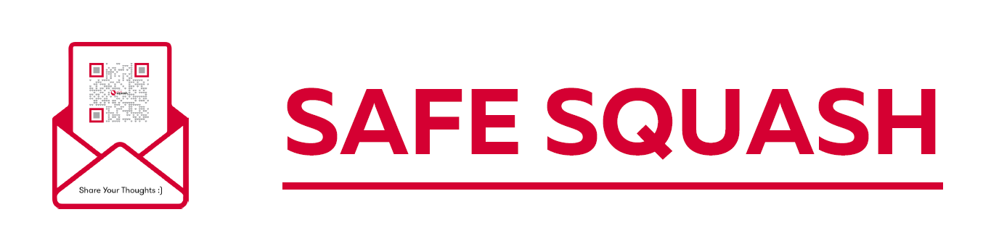

IF YOU HAVE ANY CONCERNS ABOUT YOUR SAFETY OR ARE CONCERNED ABOUT ANYONE ELSE WHILE YOU ARE AT THIS EVENT, YOU CAN TALK TO THE TOURNAMENT SAFEGUARDING LEAD IN PRIVATE
PLEASE ENSURE YOU REPORT CONCERNS IMMEDIATELY, DO NOT WAIT UNTIL THE EVENT IS OVER
TOURNAMENT SAFEGUARDING LEAD:
ADD NAME HERE
TEL NO:
ADD NO HERE
EMAIL:
EMAIL HERE

ADD PHOTO HERE



