
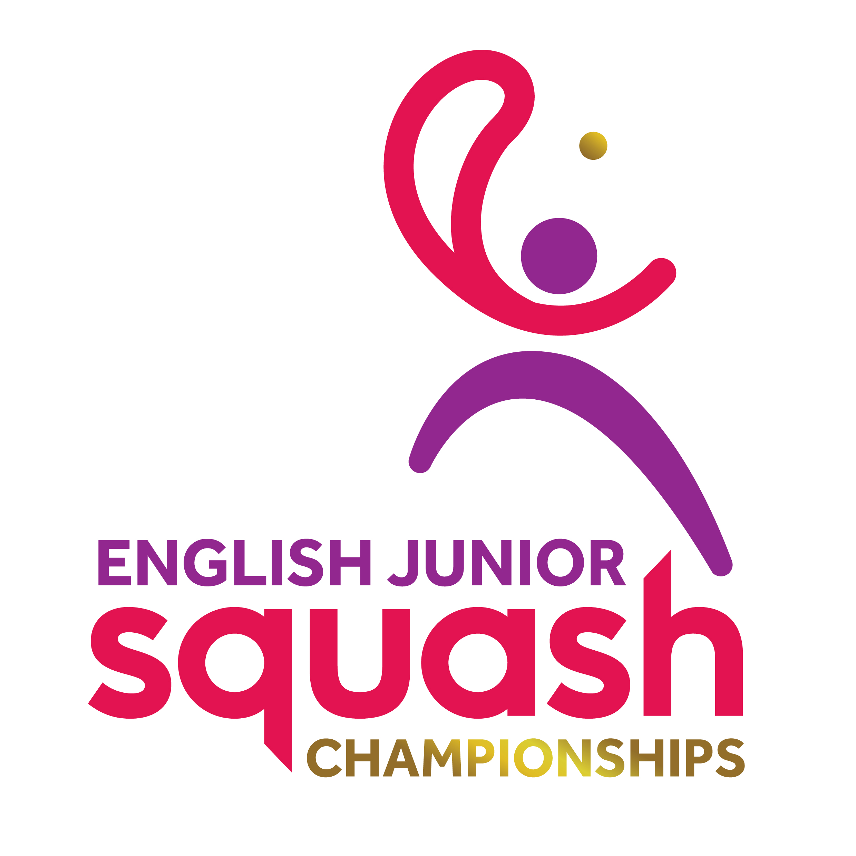

ENGLISH JUNIOR CHAMPIONSHIPS 2017
BOYS UNDER 19

First Round | Court Time | Results
[1] Kyle Finch  Michael Mattimore | FRI 12.20  EPC C1 | Kyle Finch  3-0 11/7, 13/11, 11/6
[9/16] Nick Wall  Mark Richmond | FRI 12.20  EPC C2 | Nick Wall  3-1 14/12, 11/4, 8/11, 11/5
[9/16] Joshua Owen  Ben Merchant | FRI 12.20  EPC C3 | Joshua Owen  3-0 11/8, 11/7, 11/4
[5/8] Elliot Ridge  Alexander Engstrom | FRI 12.20  EPC C4 | Elliot Ridge  3-0 11/4, 11/4, 11/7
[5/8] Tom Walsh  Joseph Blackmur | FRI 12.20  EPC C7 | Tom Walsh  3-0 11/2, 11/3, 11/4
[9/16] Paul Broadberry  Jordan Warne | FRI 12.20  EPC C8 | Jordan Warne  3-2 6/11, 11/5, 7/11, 11/9, 11/9
[9/16] Toby Harding  Joshua Attwell | FRI 12.20  EPC C9 | Toby Harding  3-1 11/4, 14/12, 6/11, 11/5
[3/4] Harry Falconer  Yusef Forster | FRI 12.20  EPC C10 | Harry Falconer  3-1 8/11, 11/5, 11/6, 11/2
[3/4] Adam Corcoran  Robert Thirst | FRI 13.40  EPC C1 | Adam Corcoran  3-0 11/4, 11/2, 11/0
[9/16] Michael Andrews  George Sawrey Cookson | FRI 13.40  EPC C2 | Michael Andrews  3-2 11/7,6/11, 11/7, 8/11, 11/4
[9/16] Aaron Allpress  William Henden | FRI 13.40  EPC C3 | Aaron Allpress  3-0 11/9, 11/3, 11/9
[5/8] Stuart MacGregor  Lucas Hughes | FRI 13.40  EPC C4 | Stuart MacGregor  3-0 11/6, 11/5, 11/4
[5/8] Curtis Malik  Odhran Imlah | FRI 13.40  EPC C7 | Curtis Malik  3-0 11/3, 11/2, 11/2
[9/16] Hasnaat Farooqi  Carlton Oldham | FRI 13.40  EPC C8 | Carlton Oldham  12/10, 11/9, 15/13, 11/5, 12/10
[9/16] James Wyatt  Cameron Haddow | FRI 13.40  EPC C9 | James Wyatt  3-0 11/8, 11/4, 11/6
Kieran Heaphy  [2] Charlie Lee | FRI 13.40  EPC C10 | Charlie Lee

Second Round  Last 16 | Court  Time | Results

Kyle Finch | FRI 20.20  EPC C1 | Kyle Finch  w/o
Nick Wall | FRI 20.20  EPC C1 | Kyle Finch  w/o
Joshua Owen | FRI 20.20  EPC C2 | Elliot Ridge  3-1 11/9, 11/13, 11/4, 11/5
Elliot Ridge | FRI 20.20  EPC C2 | Elliot Ridge  3-1 11/9, 11/13, 11/4, 11/5
Tom Walsh | FRI 20.20  EPC C3 | Tom Walsh  3-0 11/2, 11/4, 11/6
Jordan Warne | FRI 20.20  EPC C3 | Tom Walsh  3-0 11/2, 11/4, 11/6
Toby Harding | FRI 20.20  EPC C4 | Harry Falconer  3-0 11/7, 11/4, 11/7
Harry Falconer | FRI 20.20  EPC C4 | Harry Falconer  3-0 11/7, 11/4, 11/7
Adam Corcoran | FRI 20.20  EPC C7 | Adam Corcoran  3-0 11/3, 11/3, 11/6
Michael Andrews | FRI 20.20  EPC C7 | Adam Corcoran  3-0 11/3, 11/3, 11/6
Aaron Allpress | FRI 20.20  EPC C8 | Stuart MacGregor  3-0 11/7, 11/9, 11/6
Stuart MacGregor | FRI 20.20  EPC C8 | Stuart MacGregor  3-0 11/7, 11/9, 11/6
Curtis Malik | FRI 20.20  EPC C9 | Curtis Malik  3-0 11/8, 11/5, 11/6
Carlton Oldham | FRI 20.20  EPC C9 | Curtis Malik  3-0 11/8, 11/5, 11/6
James Wyatt | FRI 20.20  EPC C10 | Charlie Lee  3-0 11/3, 11/8, 11/9
Charlie Lee | FRI 20.20  EPC C10 | Charlie Lee  3-0 11/3, 11/8, 11/9

Third Round  (2nd round winners competing for places 1 to 8) | Court  Time | Results

Kyle Finch | Sat 13.30  EPC 1 | Kyle Finch 3-1  11-8 4-11 11-6 11-9
Elliot Ridge | Sat 13.30  EPC 1 | Kyle Finch 3-1  11-8 4-11 11-6 11-9
Tom Walsh | Sat 13.30  EPC 2 | Tom Walsh 3-1  12-10 13-11 7-11 11-6
Harry Falconer | Sat 13.30  EPC 2 | Tom Walsh 3-1  12-10 13-11 7-11 11-6
Adam Corcoran | Sat 13.30  EPC 3 | Adam Corcaran 3-2  5-11 11-7 9-11 11-1 11-1
Stuart MacGregor | Sat 13.30  EPC 3 | Adam Corcaran 3-2  5-11 11-7 9-11 11-1 11-1
Curtis Malik | Sat 13.30  EPC 4 | Charlie Lee 3-0  11-7 11-9 11-3
Charlie Lee | Sat 13.30  EPC 4 | Charlie Lee 3-0  11-7 11-9 11-3

Third Round  (2nd round losers competing for places 9 to 16) | Court  Time | Results

Nick Wall | Sat 10.30  EPC 7 | Joshua Owen  W/O
Joshua Owen | Sat 10.30  EPC 7 | Joshua Owen  W/O
Jordan Warne | Sat 10.30  EPC 8 | Toby Harding 3-0  11-7 11-5 11-7
Toby Harding | Sat 10.30  EPC 8 | Toby Harding 3-0  11-7 11-5 11-7
Michael Andrews | Sat 10.30  EPC 9 | Michael Andrews 3-0  11-6 11-2 11-6
Aaron Allpress | Sat 10.30  EPC 9 | Michael Andrews 3-0  11-6 11-2 11-6
Carlton Oldham | Sat 10.30  EPC 10 | James Wyatt 3-0  11-5 11-9 11-5
James Wyatt | Sat 10.30  EPC 10 | James Wyatt 3-0  11-5 11-9 11-5

Fourth Round  (3rd round winners 1 to 8 competing for places 1 to 4 | Court  Time | Results

Kyle Finch | Sat 18.20  EPC 4 | Kyle Finch 3-2  11-8 6-11 11-7 6-11 11-8
Tom Walsh | Sat 18.20  EPC 4 | Kyle Finch 3-2  11-8 6-11 11-7 6-11 11-8
Adam Corcoran | Sat 19.00  EPC1 | Charlie Lee 3-2  11-6 11-9 1-11 4-11 12-10
Charlie Lee | Sat 19.00  EPC1 | Charlie Lee 3-2  11-6 11-9 1-11 4-11 12-10

Fourth Round  (3rd round losers 1 to 8 competing for places 5 to 8) | Court  Time | Results

Elloit Ridge | Sat 19.40  EPC 1 | Harry Falconer 3-2  7-11 11-5 3-11 11-6 11-3
Harry Falconer | Sat 19.40  EPC 1 | Harry Falconer 3-2  7-11 11-5 3-11 11-6 11-3
Stuart MacGregor | Sat 19.40  EPC 2 | Stuart MacGregor 3-0 12-10 11-4 11-9
Curtis Malik | Sat 19.40  EPC 2 | Stuart MacGregor 3-0 12-10 11-4 11-9

Fourth Round  (3rd round winners 9 to 16 competing for places 9 to 12) | Court  Time | Results

Joshua Owen | Sat 16.30  EPC 3 | Toby Harding 3-1  11-8 11-9 8-11 11-5
Toby Harding | Sat 16.30  EPC 3 | Toby Harding 3-1  11-8 11-9 8-11 11-5
Michael Andrews | Sat 16.30  EPC 4 | James Wyatt 3-0  11-6 11-1 14-12
James Wyatt | Sat 16.30  EPC 4 | James Wyatt 3-0  11-6 11-1 14-12

Fourth Round  (3rd round losers 9 to 16 competing for places 13 to 16) | Court  Time | Results

Nick Wall | Sat 16.30  EPC 1 | Jordan Warne  W/O
Jordan Warne | Sat 16.30  EPC 1 | Jordan Warne  W/O
Aaron Allpress | Sat 16.30  EPC 2 | Carlton Oldham  W/O
Carlton Oldham | Sat 16.30  EPC 2 | Carlton Oldham  W/O

Court  Time | Final / Play-Offs | Result | Final Position | Final  Place

Sun  14.40  EPC 2 | Kyle Finch | 3-0  11-8 11-6 11-7 | Charlie Lee | 1
Sun  14.40  EPC 2 | Charlie Lee | 3-0  11-8 11-6 11-7 | Kyle Finch | 2
Sun  14.40  EPC 4 | Adam Corcoran | 3-2  10-12 12-10  11-3 13-15 11-3 | Tom Walsh | 3
Sun  14.40  EPC 4 | Tom Walsh | 3-2  10-12 12-10  11-3 13-15 11-3 | Adam Corcoran | 4
Sun  11.40  EPC 7 | Harry Falconer | 3-2  11-8 8-11 11-13 11-5 11-6 | Stuart MacGregor | 5
Sun  11.40  EPC 7 | Stuart MacGregor | 3-2  11-8 8-11 11-13 11-5 11-6 | Harry Falconer | 6
Sun  11.40  EPC 8 | Elliot Ridge | W/O | Elliot Ridge | 7
Sun  11.40  EPC 8 | Curtis Malik | W/O | Curtis Malik | 8
Sun  11.40  EPC 9 | Toby Harding | 3-2  10-12 11-9 11-7 11-13 11-6 | Toby Harding | 9
Sun  11.40  EPC 9 | James Wyatt | 3-2  10-12 11-9 11-7 11-13 11-6 | James Wyatt | 10
Sun  11.40  EPC 10 | Joshua Owen | 3-0  11-8 11-6 11-5 | Michael Andrews | 11
Sun  11.40  EPC 10 | Michael Andrews | 3-0  11-8 11-6 11-5 | Joshua Owen | 12
Sun  12.20  EPC 7 | Jordan Warne | 3-0  11-8 11-7 11-7 | Carlton Oldham | 13
Sun  12.20  EPC 7 | Carlton Oldham | 3-0  11-8 11-7 11-7 | Jordan Warne | 14
 | Aaron Allpress |  | Aaron Allpress | 16=
 | Nick Wall |  | Nick Wall | 16=

