
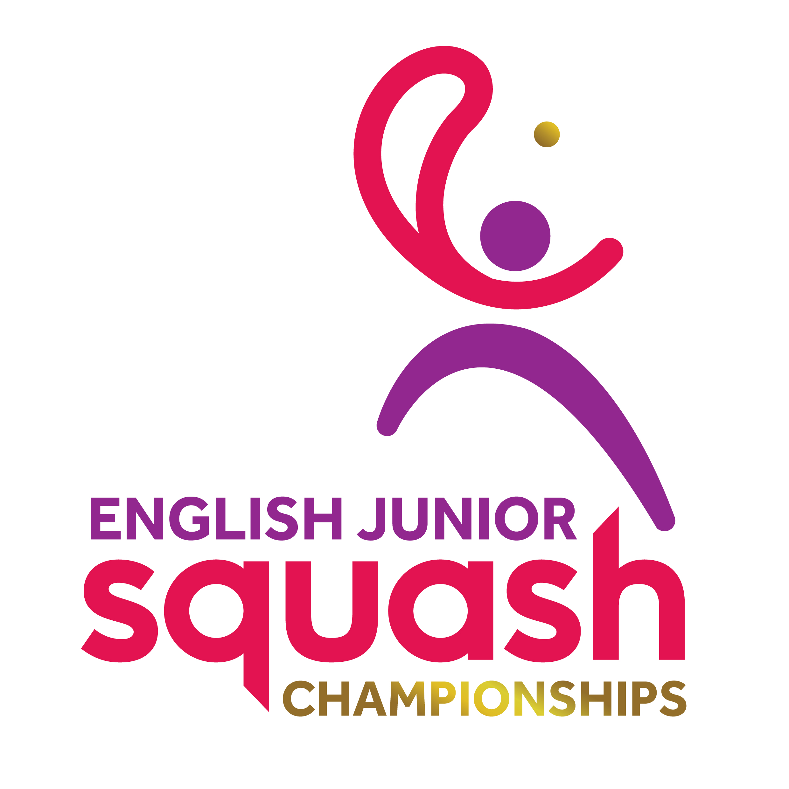

ENGLISH JUNIOR CHAMPIONSHIPS 2017
Round 1 | Q Finals | S Finals | Final
Michael Mattimore | Michael Mattimore  11/3, 11/3, 11/8
Mark Richmond
Ben Merchant | w/o Ben Merchant
Alexander Engstrom |  | Michael Mattimore  11/4, 11/8, 11/4
Joseph Blackmur | Paul Broadberry  11/5, 11/9, 11/7
Paul Broadberry
Joshua Attwell | Joshua Attwell  10/12, 14/12, 6/11, 11/1, 11/9
Yusef Forster |  | Paul Broadberry  9/11, 11/9, 11/8, 11/9 | Paul Broadberry  3-2  11/8, 5/11, 8/11, 11/1, 11/5
Robert Thirst | George Sawrey Cookson  11/5, 11/5, 11/3 | George Sawrey Cookson  14/12, 10/12, 11/9, 6/11, 14/12 | George Sawrey Cookson  3-1  11/7, 5/11, 11/9, 11/6
George Sawrey Cookson

William Henden | Lucas Hughes  11/5, 11/4, 5/11, 10/12, 11/6
Lucas Hughes
Odhran Imlah | w/o Odhran Imlah | Cameron Haddow  11/4, 11/6, 11/3
Hasnaat Farooqi

Cameron Haddow | Cameron Haddow
BYE

BOYS UNDER 19 PLATE

Paul Broadberry 3-0
11/3, 11/6, 12/10

