
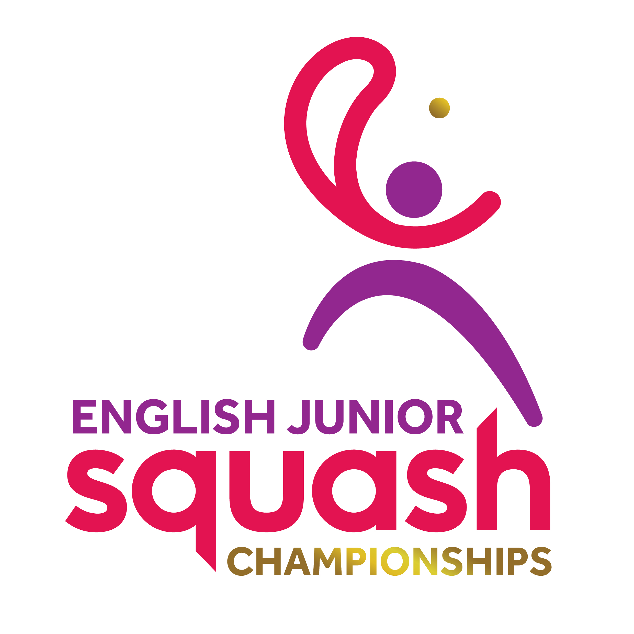

ENGLISH JUNIOR CHAMPIONSHIPS 2017
GIRLS UNDER 17

First Round | Court Time | Results
[1] Elise Lazarus  BYE |  | ELISE LAZARUS
[9/16] Alice Coxeter  Chloe Foster | FRI 11.00  UOB C2 | A. Coxeter 3-0 11-6 11-4 11-8
[9/16] Eleanor White  Aisha Forster | FRI 11.40  UOB C1 | E. White 3-0 11-9 11-7 11-8
[5/8] Lucy Green  Katie Cox | FRI 11.40  UOB C2 | L. Green 3-2 5-11 11-7 9-11 11-7 11-8
[5/8] Rosie Kirsch  Polly Clark | FRI 11.40  UOB C3 | R. Kirsch 3-0 11-4 11-8 11-1
[9/16] Grace Clark  Natalie Chak | FRI 11.40  UOB C4 | G. Clark 3-0 11-9 11-8 11-4
[9/16] Casey Miller  Phoebe Colman | FRI 11.40  UOB C5 | C. Miller 3-0 11-2 11-7 11-6
[3/4] Katie Wells  Lotti Taylor-French | FRI 11.40  UOB C6 | K. Wells 3-0 11-3 11-3 11-5
[3/4] Eve Coxon  Amy Aspinall | FRI 13.40  UOB C1 | E. Coxon 3-0 11-4 11-4 11-2
[9/16] Brieanna Boo Burki  Piper Rose Tatum | FRI 13.40  UOB C2 | B. Boo-Burki 3-0 11-9 11-4 11-3
[9/16] Lily Taylor-French  Alysha Martin | FRI 13.40  UOB C3 | L. Taylor-French 3-0 11-3 11-5 11-6
[5/8] Kiera Marshall  Lowri Waugh | FRI 13.40  UOB C4 | K. Marshall 3-0 11-1 1-2 11-2
[5/8] Katie Malliff  Paige McCoy | FRI 13.40  UOB C5 | K. Malliff 3-0 11-4 11-1 11-4
[9/16] Poppie Jaram  Darcie-Rose Mounter | FRI 13.40  UOB C6 | P. Jaram 3-0 11-7 11-4 11-9
[9/16] Margot Prow  Elli Barrott | FRI 14.20  UOB C1 | M. Prow 3-0 11-3 11-1 11-4
Sydney Wallace  [2] Alice Green | FRI 14.20  UOB C2 | A. Green 11-2 11-7 11-3

Second Round  Last 16 | Court  Time | Results

ELISE LAZARUS | FRI 19.40  EPC C1 | Elise Lazarus 3-0  11-3 11-3 11-5
Alice Coxeter | FRI 19.40  EPC C1 | Elise Lazarus 3-0  11-3 11-3 11-5
Eleanor White | FRI 19.40  EPC C2 | Lucy Green 3-0  11-8 11-5 11-8
Lucy Green | FRI 19.40  EPC C2 | Lucy Green 3-0  11-8 11-5 11-8
Rosie Kirsch | FRI 19.40  EPC C3 | Rosie Kirsch 3-0  11-4 11-5 11-7
Grace Clark | FRI 19.40  EPC C3 | Rosie Kirsch 3-0  11-4 11-5 11-7
Casey Miller | FRI 19.40  EPC C4 | Katie Wells 3-1  11-9 11-2 7-11 11-7
Katie Wells | FRI 19.40  EPC C4 | Katie Wells 3-1  11-9 11-2 7-11 11-7
Eve Coxon | FRI 19.40  EPC C9 | Eve Coxon 3-0  11-2 11-6 11-2
Brieanna Boo Burki | FRI 19.40  EPC C9 | Eve Coxon 3-0  11-2 11-6 11-2
Lily Taylor-French | FRI 19.40  EPC C10 | Keira Marshall 3-1  11-2 5-11 11-8 11-7
Keira Marshall | FRI 19.40  EPC C10 | Keira Marshall 3-1  11-2 5-11 11-8 11-7
Katie Malliff | FRI 19.40  EPC C7 | Katie Maliff 3-0  11-3 11-5 11-3
Poppie Jaram | FRI 19.40  EPC C7 | Katie Maliff 3-0  11-3 11-5 11-3
Margot Prow | FRI 19.40  EPC C8 | Alice Green 3-0  11-4 11-7 11-7
Alice Green | FRI 19.40  EPC C8 | Alice Green 3-0  11-4 11-7 11-7

Third Round  (2nd round winners competing for places 1 to 8) | Court  Time | Results

Elise Lazarus | Sat 12.50  EPC 1 | Elise Lazarus 3-0  11-5 11-5 11-4
Lucy Green | Sat 12.50  EPC 1 | Elise Lazarus 3-0  11-5 11-5 11-4
Rosie Kirsch | Sat 12.50  EPC 2 | Katie Wells 3-1  11-8 11-9 5-11 11-8
Katie Wells | Sat 12.50  EPC 2 | Katie Wells 3-1  11-8 11-9 5-11 11-8
Eve Coxon | Sat 12.50  EPC 3 | Eve Coxon 3-0  11-6 11-8 11-6
Keira Marshall | Sat 12.50  EPC 3 | Eve Coxon 3-0  11-6 11-8 11-6
Katie Maliff | Sat 12.50  EPC 4 | Katie Maliff 3-1  11-3 11-5 6-11 11-8
Alice Green | Sat 12.50  EPC 4 | Katie Maliff 3-1  11-3 11-5 6-11 11-8

Third Round  (2nd round losers competing for places 9 to 16) | Court  Time | Results

Alice Coxeter | Sat 10.00  EPC 7 | Alice Coxeter 3-0  11-7 11-5 11-3
Eleanor White | Sat 10.00  EPC 7 | Alice Coxeter 3-0  11-7 11-5 11-3
Grace Clark | Sat 10.00  EPC 8 | Grace Clark 3-0  11-4 12-10 11-6
Casey Miller | Sat 10.00  EPC 8 | Grace Clark 3-0  11-4 12-10 11-6
Brieanna Boo Burki | Sat 10.00  EPC 9 | Lily Taylor-French 3-1  9-11 11-3 12-10 11-3
Lily Taylor-French | Sat 10.00  EPC 9 | Lily Taylor-French 3-1  9-11 11-3 12-10 11-3
Poppie Jaram | Sat 10.00  EPC 10 | Margot Prow 3-1  8-11 11-5 11-2 11-3
Margot Prow | Sat 10.00  EPC 10 | Margot Prow 3-1  8-11 11-5 11-2 11-3

Fourth Round  (3rd round winners 1 to 8 competing for places 1 to 4 | Court  Time | Results

Elise Lazarus | Sat18.20  EPC 1 | Elise Lazarus 3-0  11-3 11-6 11-2
Katie Wells | Sat18.20  EPC 1 | Elise Lazarus 3-0  11-3 11-6 11-2
Eve Coxon | Sat 19.00  EPC 4 | Eve Coxon 3-1  11-9 5-11 11-9 11-7
Katie Maliff | Sat 19.00  EPC 4 | Eve Coxon 3-1  11-9 5-11 11-9 11-7

Fourth Round  (3rd round losers 1 to 8 competing for places 5 to 8) | Court  Time | Results

Lucy Green | Sat 19.40  EPC 7 | Rosie Kirsch 3-0  11-4 11-9 11-5
Rosie Kirsch | Sat 19.40  EPC 7 | Rosie Kirsch 3-0  11-4 11-9 11-5
Keira Marshall | Sat 19.40  EPC 8 | Alice Green  W/O
Alice Green | Sat 19.40  EPC 8 | Alice Green  W/O

Fourth Round  (3rd round winners 9 to 16 competing for places 9 to 12) | Court  Time | Results

Alice Coxeter | Sat 16.30  EPC7 | Grace Clark 3-0  11-6 11-6 11-5
Grace Clark | Sat 16.30  EPC7 | Grace Clark 3-0  11-6 11-6 11-5
Lily Taylor-French | Sat 16.30  EPC 8 | Margot Prow 3-1  12-14 11-7 11-8 11-8
Margot Prow | Sat 16.30  EPC 8 | Margot Prow 3-1  12-14 11-7 11-8 11-8

Fourth Round  (3rd round losers 9 to 16 competing for places 13 to 16) | Court  Time | Results

Eleanor White | 16.30  EPC9 | Eleanor White 3-2  11-8 11-5 8-11 9-11 11-6
Casey Miller | 16.30  EPC9 | Eleanor White 3-2  11-8 11-5 8-11 9-11 11-6
Brieanna Boo Burki | Sat 16.30  EPC10 | Poppie Jaram 3-1  7-11 11-8 11-4 11-7
Poppie Jaram | Sat 16.30  EPC10 | Poppie Jaram 3-1  7-11 11-8 11-4 11-7

Court  Time | Final / Play-Offs | Result | Final Position | Final  Place

Sun  13.40  EPC3 | Elise Lazarus | 3-0  11-4 11-5 11-6 | Elise Lazarus | 1
Sun  13.40  EPC3 | Eve Coxon | 3-0  11-4 11-5 11-6 | Eve Coxon | 2
Sun  13.40  EPC1 | Katie Wells | 3-0  13-11 13-11  11-5 | Katir Maliff | 3
Sun  13.40  EPC1 | Katie Maliff | 3-0  13-11 13-11  11-5 | Katie Wells | 4
Sun  10.40  EPC 1 | Alice Green | 3-0  11-4 11-1 11-3 | Alice Green | 5
Sun  10.40  EPC 1 | Rosie Kirsch | 3-0  11-4 11-1 11-3 | Rosie Kirsch | 6
 | Lucy Green | W/O | Lucy Green | 7
 | Keira Marshall | W/O | Keira Marshall | 8
Sun 10.40  EPC 3 | Grace Clark | 3-1  9-11 11-9 11-4 13-11 | Margot Prow | 9
Sun 10.40  EPC 3 | Margot Prow | 3-1  9-11 11-9 11-4 13-11 | Grace Clark | 10
Sun 10.40  EPC 4 | Alice Coxeter | 3-0  11-5 12-10 11-8 | Lily Taylor-French | 11
Sun 10.40  EPC 4 | Lily Taylor-French | 3-0  11-5 12-10 11-8 | Alice Coxeter | 12
Sun 10.40  EPC 7 | Eleanor White | 3-0  11-9 11-7 11-8 | Poppie Jaram | 13
Sun 10.40  EPC 7 | Poppie Jaram | 3-0  11-9 11-7 11-8 | Eleanor White | 14
Sun 10.40  EPC 8 | Casey Miller | 3-1  11-7 9-11 16-14 11-8 | Brieanna Boo Burki | 15
Sun 10.40  EPC 8 | Brieanna Boo Burki | 3-1  11-7 9-11 16-14 11-8 | Casey Miller | 16

