
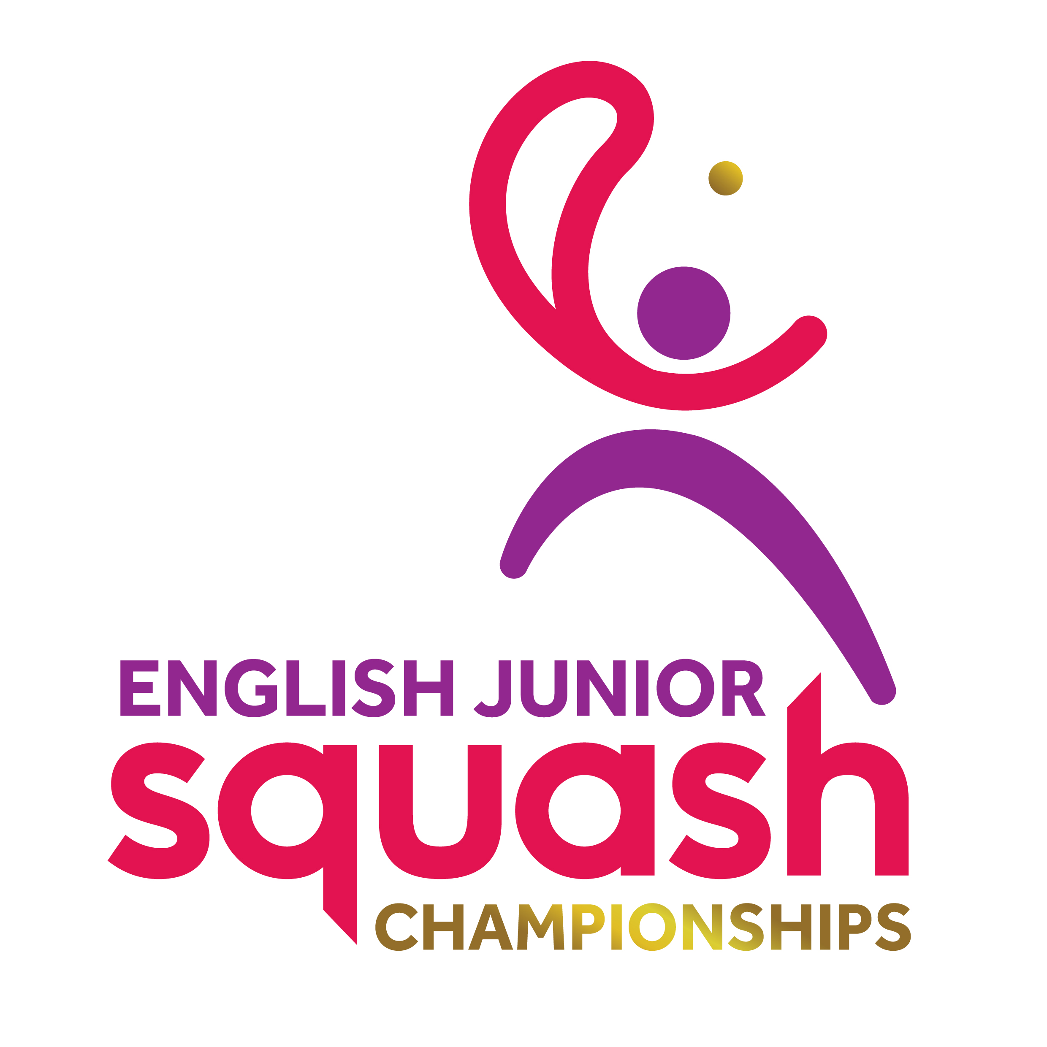

ENGLISH JUNIOR CHAMPIONSHIPS 2017
GIRLS UNDER 19

First Round  Last 16 | Court  Time | Results

[1] Lucy Turmel  BYE |  | LUCY TURMEL
[5/8] Leanne Herbert  Isabelle Johnson | FRI 15.00  EPC C2 | Leanne Herbert  3-0 11/7, 11/4, 11/7
[5/8] Gabriella Mawson  Carys Jones | FRI 15.00  EPC C3 | Carys Jones  3-2 11/7, 5/11, 7/11, 11/6, 11/8
[3/4] Charlotte Jagger  Jemma Stanton - W/D |  | CHARLOTTE JAGGER
[3/4] Jasmine Hutton  Emily Westall | FRI 15.00  EPC C7 | Jasmine Hutton  3-0 11/4, 11/7, 11/5
[5/8] Amy Jones  Rawan Elkalaawy | FRI 15.00  EPC C8 | Amy Jones  3-0 11/2, 11/8, 11/8
[5/8] Josie Barker  Charlotte Fish | FRI 15.00  EPC C9 | Josie Barker  3-1 11/8, 6/11, 11/6, 11/8
Jasmin Kalar  [2] Grace Gear | FRI 15.00  EPC C10 | Grace Gear  3-0 11/2, 11/1, 11/6

Second Round  (1st round winners competing for places 1 to 8) | Court  Time | Results

Lucy Turmel | SAT 13.30  EPC C7 | Lucy Turmel 3-0  11-5 11-2 11-5
Leanne Herbert | SAT 13.30  EPC C7 | Lucy Turmel 3-0  11-5 11-2 11-5
Carys Jones | SAT 13.30  EPC C8 | Carys Jones 3-1  11-9 9-11 11-9 11-9
Charlotte Jagger | SAT 13.30  EPC C8 | Carys Jones 3-1  11-9 9-11 11-9 11-9
Jasmine Hutton | SAT 13.30  EPC C9 | Jasmine Hutton 3-1  11-5 11-9 11-13 11-8
Amy Jones | SAT 13.30  EPC C9 | Jasmine Hutton 3-1  11-5 11-9 11-13 11-8
Josie Barker | SAT 13.30  EPC C10 | Grace Gear 3-0  11-5 11-7 11-7
Grace Gear | SAT 13.30  EPC C10 | Grace Gear 3-0  11-5 11-7 11-7

Second Round  (1st round losers competing for places 9 to 16) | Court  Time | Results

BYE | SAT 10.00  EPC C1 | Isabelle Johnson
Isabelle Johnson | SAT 10.00  EPC C1 | Isabelle Johnson
Gabriella Mawson | SAT 10.00  EPC C2 | Gabriella Mawson
BYE | SAT 10.00  EPC C2 | Gabriella Mawson
Emily Westall | SAT 10.00  EPC C3 | Emily Westall 3-2  5-11 9-11 11-6 11-6 11-7
Rawan Elkalaawy | SAT 10.00  EPC C3 | Emily Westall 3-2  5-11 9-11 11-6 11-6 11-7
Charlotte Fish | SAT 10.00  EPC C4 | Jasmin Kalar 3-1  11-9 11-9 4-11 15-13
Jasmin Kalar | SAT 10.00  EPC C4 | Jasmin Kalar 3-1  11-9 11-9 4-11 15-13

Third Round  (2nd round winners 1 to 8 competing for places 1 to 4) | Court  Time | Results

Lucy Turmel | Sat 18.20  EPC 3 | Lucy Turmel 3-0  11-0 11-3 11-1
Carys Jones | Sat 18.20  EPC 3 | Lucy Turmel 3-0  11-0 11-3 11-1
Jasmine Hutton | Sat 19.00  EPC 2 | Grace Gear 3-2  8-11 11-5 11-8 8-11 11-9
Grace Gear | Sat 19.00  EPC 2 | Grace Gear 3-2  8-11 11-5 11-8 8-11 11-9

Third Round  (2nd round losers 1 to 8 competing for places 5 to 8) | Court  Time | Results

Leanne Herbert | Sat 19.40  EPC 3 | Charlotte Jagger 3-0  11-6 11-6 11-6
Charlotte Jagger | Sat 19.40  EPC 3 | Charlotte Jagger 3-0  11-6 11-6 11-6
Amy Jones | Sat 19.40  EPC 4 | Amy Jones 3-2  12-10 7-11 6-11 11-7 11-8
Josie Barker | Sat 19.40  EPC 4 | Amy Jones 3-2  12-10 7-11 6-11 11-7 11-8

Third Round  (2nd round winners 9 to 16 competing for places 9 to 12) | Court  Time | Results

Isabelle Johnson | Sat 15.50  EPC 1 | Gabriella Mawson 3-0 11-5 11-7 11-2
Gabriella Mawson | Sat 15.50  EPC 1 | Gabriella Mawson 3-0 11-5 11-7 11-2
Emily Westall | Sat 15.50  EPC 2 | Emily Westall 3-0  11-3 11-8 11-5
Jasmin Kalar | Sat 15.50  EPC 2 | Emily Westall 3-0  11-3 11-8 11-5

Third Round  (2nd round losers 9 to 16 competing for places 13 to 16) | Court  Time | Results

BYE | Sat 15.50  EPC 3 | BYE
BYE | Sat 15.50  EPC 3 | BYE
Rawan Elkalaawy | Sat 15.50  EPC 4 | Rawan Elkalaawy  W/O
Charlotte Fish | Sat 15.50  EPC 4 | Rawan Elkalaawy  W/O

Court  Time | Final / Play-Offs | Result | Final Position | Final  Place

Sun  14.40  EPC 3 | Lucy Turmel | 3-0  12-10 11-6 11-4 | Lucy Turmel | 1
Sun  14.40  EPC 3 | Grace Gear | 3-0  12-10 11-6 11-4 | Grace Gear | 2
Sun  14.40  EPC 1 | Carys Jones | 3-0  11-8 11-3 11-6 | Jasmine Hutton | 3
Sun  14.40  EPC 1 | Jasmine Hutton | 3-0  11-8 11-3 11-6 | Carys Jones | 4
Sun  12.20  EPC 9 | Amy Jones | 3-1  11-8 11-9 4-11 11-6 | Charlotte Jagger | 5
Sun  12.20  EPC 9 | Charlotte Jagger | 3-1  11-8 11-9 4-11 11-6 | Amy Jones | 6
Sun  12.20  EPC 10 | Josie Barker | 3-1  12-10 10-12 11-4 11-5 | Josie Barker | 7
Sun  12.20  EPC 10 | Leanne Herbert | 3-1  12-10 10-12 11-4 11-5 | Leanne Herbert | 8
Sun  13.00  EPC 7 | Gabrielle Mawson | 3-1  8-11 11-9 11-2 4-2 Rtd | Emily Westall | 9
Sun  13.00  EPC 7 | Emily Westall | 3-1  8-11 11-9 11-2 4-2 Rtd | Gabrielle Mawson | 10
Sun  13.00  EPC 8 | Isabelle Johnson | W/O | Isabelle Johnson | 11
Sun  13.00  EPC 8 | Jasmin Kalar | W/O | Jasmin Kalar | 12
 | Rawan ElKalaawy | W/O | Rawan ElKalaawy | 13
 | Charlotte Fish | W/O | Charlotte Fish | 14
 |  |  |  | 15
 |  |  |  | 16

