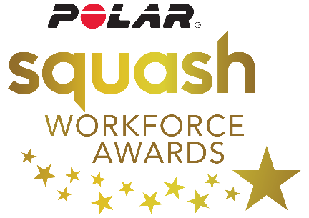

Polar Squash Workforce Awards 2017-18
Nomination form
Thank you for taking the time to nominate your squash unsung hero!
Please complete all sections below and return to joanna.rowbottom@englandsquash.com
Nominations close on 2nd January 2018.
- Please indicate in the box below which award category from the following you are nominating the person for:
- Coach of the Year
- Special Recognition Award
- Volunteer of the Year
- The Tony Parker Award: Referee of the Year

- Please provide contact details of nominated person:
Name of nominated person/ /project/venue:
County:

Email address:

- Please provide your contact details
Name of nominator:
Telephone number:
Email address:
Relationship to coach/volunteer:

- Sum up in no more than 250 words why you are nominating this person for this particular award?

- What was this person’s greatest achievement in 2017 and how has this impacted on
their squash facility/club/county/players etc? (Any evidence or statistics you could provide in this section would be useful)?

- What makes this person stand out from those around them? What is it that sets them aside and gives them the ‘X-factor?

- Has this person received any awards/recognition for their work in 2017?

Please return your form via email to joanna.rowbottom@englandsquash.com or by post to Polar Squash Workforce Awards Team, England Squash, National Squash Centre, Rowsley Street, Manchester. M113FF.

